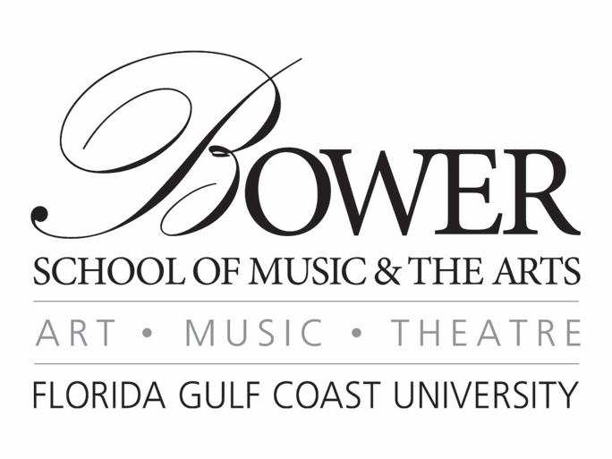

Margins=Narrow
Font=Book Antiqua
Save document as name & recital date (Ex: Alana Nanz 1-20-18)
Delete red text before submitting program

Name, instrument
Junior Piano Recital

Accompanied by Name, instrument
Assisted by Name, insturment
If performers aren’t playing on the majority of the program, they should be listed under the pieces they’re playing, not on the cover.

January 20, 2019
3:00 pm

U. Tobe Recital Hall

Program

Symphony No. 4 in A Major Felix Mendelssohn
op. 90 (“Italian”) (1808-1847)
Allegro vivace
Andanate con moto
Con moto moderato
Saltarello: Presto

Die schöne Müllerin Franz Schubert
2. Wohin? (1797-1828)
11. Mein!
14. Der Jäger

Nessun dorma Giacomo Puccini
From Turandot (1858-1924)

Featured Soloist Name, instrument

Intermission

The Promenade Overture John Corigliano
(b. 1938)

From the studio of insert applied instructor
This recital is presented in partial fulfillment of the requirements
for the degree Bachelor of insert degree

See Style Guide for More Details on Program Formatting

