Program Notes, continued

Program Notes if needed

Or Bower School of Music information will be provided

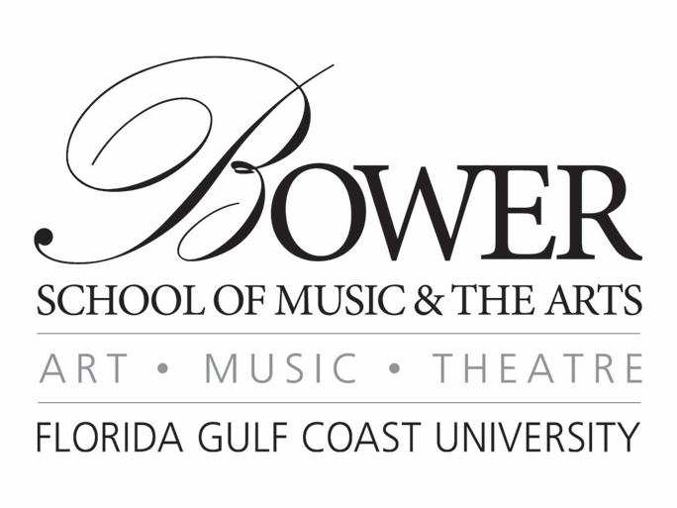

Margins=Narrow
Font=Book Antiqua
Save document as name & recital date (Ex: Alana Nanz 1-20-18)
Delete red text before submitting program

Name, instrument
Junior Piano Recital

Accompanied by Name, instrument
Assisted by Name, insturment
If performers aren’t playing on the majority of the program, they should be listed under the pieces they’re playing, not on the cover.

January 20, 2019
3:00 pm

U. Tobe Recital Hall

Program

Symphony No. 4 in A Major Felix Mendelssohn
op. 90 (“Italian”) (1808-1847)
Allegro vivace
Andanate con moto
Con moto moderato
Saltarello: Presto

Die schöne Müllerin Franz Schubert
2. Wohin? (1797-1828)
11. Mein!
14. Der Jäger

Mass No. 1 in F Major Franz Schubert

Nessun dorma Giacomo Puccini
From Turandot (1858-1924)

Featured Soloist Name, instrument

Intermission

The Promenade Overture John Corigliano
(b. 1938)

See Style Guide for More Details on Program Formatting

From the studio of insert applied instructor
This recital is presented in partial fulfillment of the requirements
for the degree Bachelor of insert degree
Program Notes

Henry Purcell was an English composer. He is mainly known to be the most important English composer of his time period. He has a talent of putting counterpoint to a very expressive and flexible text setting. Purcell was very excellent with how the text and the music flowed together in a piece. He was also very clever with setting the text “If music be the food of love” since in the Baroque time period, the word dying was symbolic for consummating love and possibly meant something “inappropriate” in Purcell’s situation. This song is using music as a metaphor for his lover because in the last line of music it states “I must perish by your charms.”

10pt Book Antiqua font
Full justification, single space
See Style Guide for Details on How to Write Program Notes

