|  |  |  |
| --- | --- | --- |
| **8:00 – 8:25** | **BREAKFAST** |  |
| 8:25 | **WELCOME by: Dr. Ron Toll**  Florida Gulf Coast University Provost |  |
| 8:30 – 9:15 | **Richard Weiskoff**  University of Miami  Department of International Studies | Overview of Calculating Values of Conservation Lands  Sponsored by: Southwest Florida Coastal Watersheds New Florida 2010 Cluster Grant |
| 9:25 – 9:40 | **Dennis Gilkey**  CEO and Managing Principal  Gilkey Organization | Economic and Marketing Benefits of Conservation Lands to Real Estate |
| 9:45 – 10:05 | **Bill Hammond**  Natural Context | How Money Has Talked to Save Natural Systems in Southwest Florida |
| 10:05 – 10:30 | **WORKING BREAK** | Sharing values of greatest importance to participants. |
| 10:35 – 10:50 | **Lisa Beever**  Director  Charlotte Harbor National Estuary Program | Conservation Lands Save Infrastructure Dollars |
| 10:55 – 11:10 | **Tamara Pigott**  Executive Director, Lee County Visitor and Convention Bureau | The Critical Link Between Conservation Land and Tourism –  Using Nature as an Economic Engine |
| 11:15 – 11:30 | **Chuck Adams**  Marine Economics Specialist  **Betty Staugler**  Marine Extension Agent  Florida Sea Grant, University of Florida | Marine Recreational and Commercial Industries and Activities in Lee County, Florida –  Economic Consequences and Impacts |
| 11:30 – 12:30 | **LUNCH**  (Provided Onsite)  Sponsored by: ECO-Action  An FGCU registered student organization | ECO-Action logo |
| 12:30 – 1:30 | **Chris Joyce**  NPR Science Correspondent  Sponsored by FGCU:  Journalism Program  College of Arts and Sciences, and  Honors Program | Explaining Conservation to the Rest of us; or,  “Excuse me, what’s Ecosystem Services?” |
| 1:30 – 1:45  1:50 – 2:05 | **Tanya Borisova** and **Laila Racesvskis**  Food & Resource Economics, UF  **Ed Hanlon**  Soil and Water Science; SW FL Research and Education Center  **Jim Beever**  Principal Planner  Southwest Regional Planning Council | Economic Value of Conservation and Agriculture Lands for Ecosystem Services  Economic Value of Ecosystem Services Provided by Natural Habitats on Conservation Lands of SW Florida |
| 2:10 – 2:25 | **Jennifer Hecker**  Director, Natural Resource Policy  Conservancy of Southwest Florida | Economic Benefit of Land Conservation in Protecting Water Resources |
| 2:30 – 3:00 | **AFTERNOON BREAK** |  |
| 3:00 – 3:15 | **Karen Bickford**  Lee County Department of Natural Resources | Achieving Water Quality Goals Through Natural Systems |
| 3:20 – 3:35 | **Robert Brooks**  Parks Manager  Koreshan State Historic Site and Estero Bay Preserve State Park | The Benefit of Florida State Parks to Local Communities |
| 3:40 – 3:55 | **Kirk Beck**  Beck & Company, LLC | Using Regulatory Currency to Purchase Conservation Lands |
| 4:00 – 4:20 | **Win Everham**  Florida Gulf Coast University  Department of Marine and Ecological Sciences | The Un-Quantifiable Values of Conservation Lands |
| 4:25 – 5:00 | **ROUNDTABLE** | Applications of Conservation Lands  Economic Benefits for Policy Makers |
| **SUMMARY AND CLOSING** | | |

**Thank you to today’s sponsors!**

**[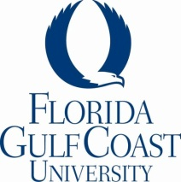](http://www.fgcu.edu/)**  [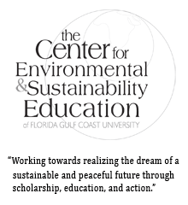](http://www.fgcu.edu/cese/) [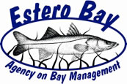](http://www.swfrpc.org/abm.html)   [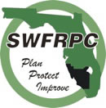](http://www.swfrpc.org/)

[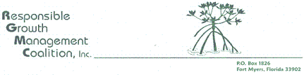](http://itech.fgcu.edu/faculty/ndemers/CelaTega%202011/www.rgmcswf.org) [](http://www.happehatchee.org/) [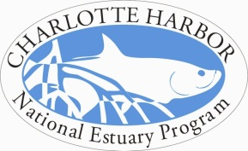](http://www.chnep.org/)

**League of Women Voters of Lee County**

**FGCU College of Arts & Sciences**

**FGCU Journalism Program**

**FGCU Honors Program**