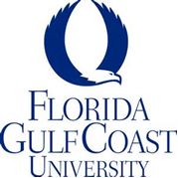

FOR IMMEDIATE RELEASE
Fort Myers, Florida - May 2, 2019

3rd Annual FGCU High School Ethics Case Competition Results
Hosted by FGCU’s Lutgert College of Business, Uncommon Friends Foundation, and Lee County Schools

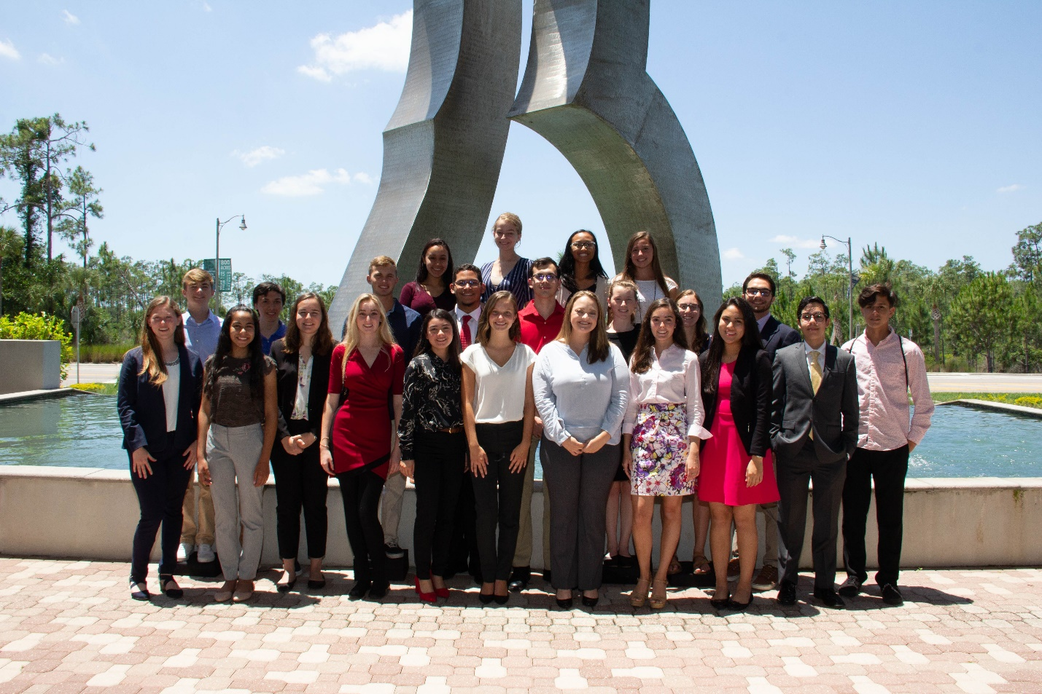Several students from the competition

FORT MYERS, Fla. – Florida Gulf Coast University’s Lutgert College of Business held its third annual high school ethics case competition recently. The competition was co-sponsored by Uncommon Friends Foundation and Lee County Schools and attended by high school students from throughout Southwest Florida. The keynote speaker was Brian Rist of Storm Smart Industries, who also provided $500 scholarships to each of the students on the winning team.

Dr. Eric B. Dent, FGCU’s Uncommon Friends Endowed Chair Professor of Ethics, selected a case in which students were faced with a real-life ethical dilemma of a college intern who found her clients were billed for more time than she actually worked and at a higher billing rate.

The winning team consisted of students Kaili Yap, Hannah VanDress, Megan Piller, Graham Kupsaw, and Samuel Bejarano. from Bishop Verot High School and Zach Taylor from Crosspointe Academy, facilitated by Bishop Verot teacher James Orr.

“Seeing the High School students grappling with a real-life ethical dilemma, taking a Saturday to think about ethics, and presenting their solution in a professional manner gave me great hope for the future,” said Dr. Karen Serrell, co-host of the event, Uncommon Friends Foundation board member, and Colonial Elementary School teacher.

“Take care of your employees, who will take care of your customers, and the business will take care of itself” was one of the many important ethical points illustrated by Brian Rist in the keynote luncheon speech.

High school students interested in participating in the FGCU ethics competition to be held in 2020 should contact Dr. Dent.

For more information, contact Dr. Eric B. Dent, edent@fgcu.edu, (239) 590-7162

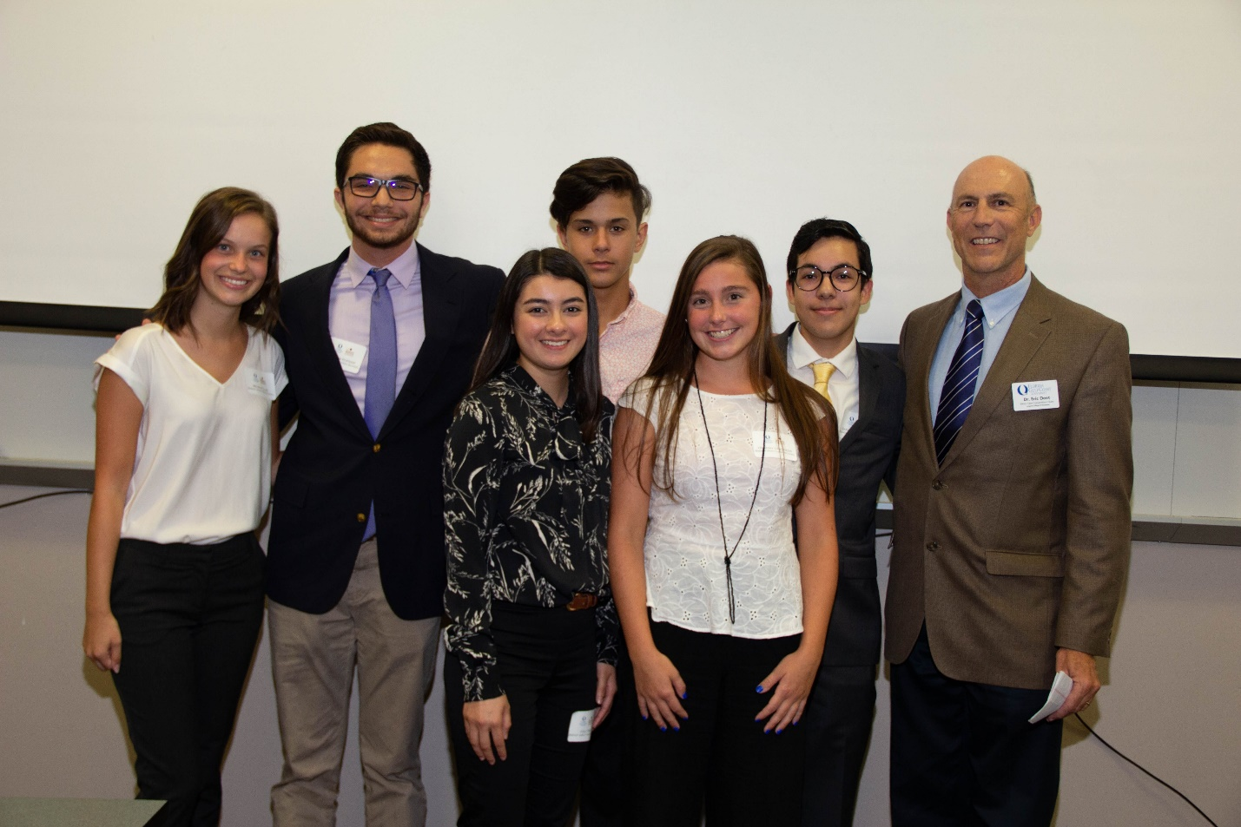
1st place team – L-R (front row) Kaili Yap, Hannah VanDress. (back row) Megan Piller, Graham Kupsaw, Zach Taylor, Samuel Bejarano, Dr. Eric B. Dent

END

