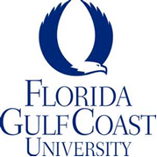

FOR IMMEDIATE RELEASE

FGCU Excels in the international Templeton Business Ethics Case Competition

Fort Myers, FL February 23, 2022

Florida Gulf Coast University’s Lutgert College of Business Ethics Case Competition
Team recently contested the Templeton Business Ethics Case Competition hosted by Stetson University. This North American competition includes teams from Canada and Mexico, as well as American universities such as Penn State University, Iowa State University, Northern Illinois University, and The University of Florida, The FGCU team consisted of students Thomas Danzi and Stephanie Moad led by faculty advisor Dr. Eric Dent, Uncommon Friends Endowed Chair Professor of Ethics.

The FGCU team had its best finish yet in an international competition. They won their division, besting universities such as Georgetown University who was the runner up. Danzi and Moad went on to finish fourth overall. The competition was won by Campbell University.

The students received the case study of a real current policy issue “Building Codes and the Climate Crisis: The International Code Council and Stakeholder Alignment” where they had to advise the ICC CEO and executive leadership team about their process for the upcoming code development cycle, a process that has a tremendous impact on the United States reaching the targets in the Paris Climate Accord, for example. The students spent weeks preparing a comprehensive ethical, legal, and financial analysis.

Two judges came from SW Florida, both representing companies that have won the Uncommon Friends Foundation Business Ethics Award - Helena Dabrowski (Sunshine Ace) and Theo Etzel (Conditioned Air). Mr. Etzel commented "The judges were all very impressed with not only the delivery styles that both FGCU students brought to the competition, but the logic and well thought out facets of the case. They made a persuasive argument for their recommendations and delivered them with a polished style."

Mr. Danzi commented that, “being able to compete in the Templeton Business Ethics Competition allowed me to grow as a researcher, presenter, and team member, and provided me the skills I need to succeed in the workplace.”

Dr. Dent remarked, “I felt better going into the award ceremony than I have with any previous team, but so many teams do such a great job that you never know what the judges will prefer. These competitions are high-impact ways for students to truly understand business and ethics.”

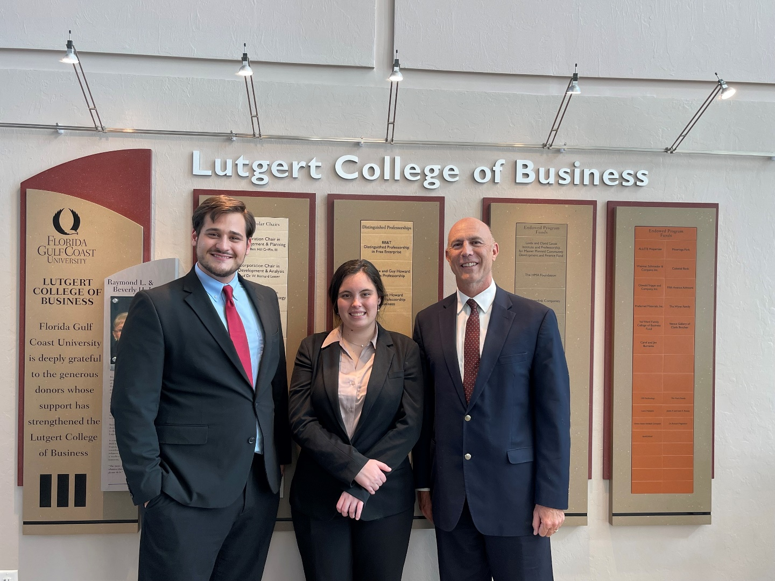
The FGCU Ethics Case Competition Team – L-R Danzi, Moad, Dr. Dent

For more information, contact Dr. Eric B. Dent, edent@fgcu.edu, (239) 590-7162

END

