Child and Youth Studies Program
Field Experience & Practicum Handbook
A guide for students, site supervisors, and university supervisors

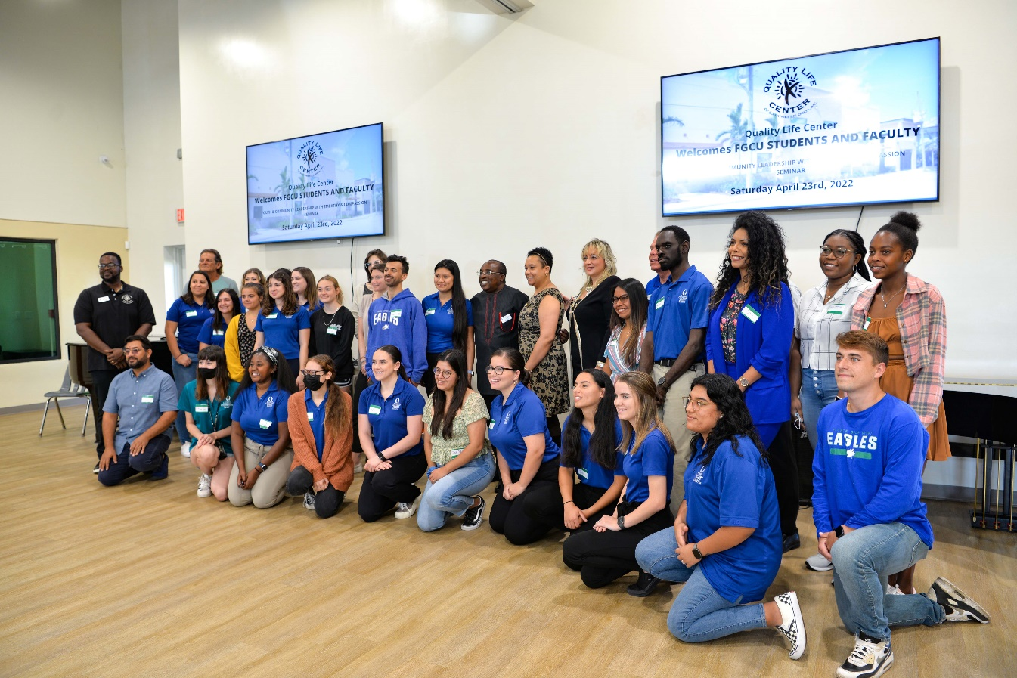

Florida Gulf Coast University College of Education

Revised August 2022

Table of Contents

Topic | Page Number(s)
College of Education CYS Student Handbook Affidavit | 4
Introduction | 5-6
Careers | 7
Faculty and Staff contacts | 8
High Quality Professional & Program Sequence | 9-12
Background of the Program | 13-14
Reflective Practice | 15-16
Selecting an Internship | 17
Application and Placement Procedure | 18
Guidelines for Placement  - Fingerprinting | 19-22
- Corporal Punishment
Roles and Responsibilities  - Responsibilities of Interning Students  - Responsibilities of the Site supervisor  - Responsibilities of the University Supervisor |  | 23-25
Procedure to Follow if Problems Arise |  | 26
Policy on Intervention and/or Removal of the Student |  | 27
Intervention Guidelines |  | 28
Criteria for a passing grade in field experience  - Receiving a Grade of Unsatisfactory |  | 29
Appendices:  - Appendix A: Student Field Experience Checklist  - Appendix B: Site supervisor Checklist  - Appendix C: University Supervisor Checklist  - Appendix D: Field Experience Student Observation Forms  - Appendix E: Disposition Assessment Form |  | 30-37
CYS Observation Forms | 38-44

College of Education CYS Student Handbook Affidavit

Dear students,
It is my pleasure to welcome you to the internship component of the Child and Youth Studies (CYS) program through this handbook. This document contains policies and procedures of the CYS program at Florida Gulf Coast University. You are required to read and understand this document in its entity before venturing into the internship (Field experience or Practicum). You should also be referring to it regularly during your internship to understand what is required of you. Please complete this affidavit after reading the handbook and sharing it with your site supervisor and university supervisor.
I______________________ sign this affidavit as proof of having read and understood the requirements of this handbook. By signing this document, I am attesting that I agree, accept, understand, and therefore will strictly abide by the policies and procedures of the student practicum/field experience program at Florida Gulf Coast University. A copy of the signed affidavit will be placed in my personal file in the College of Education Internship Office no later than the end of the first week of the semester of the practicum or field experience.
Student’s Printed Name _________________________________________________
Student’s Signature

University Supervisor

Site Supervisor _________________________________________________________

Have this affidavit signed by all and bring with you to your Field Experience/Practicum Orientation or submit it no later than end of the first week.

Peter Ndiang’ui, Ed.D, CFLE
CYS Program Coordinator

Introduction

The Student Handbook is intended to inform you and the community partners about policies and procedures concerning the internship. It has been created to clearly identify the roles and responsibilities of all persons involved in the internship process. Student field experiences and practicum will provide opportunities for students to apply educational theory in real-life situations such as; Diagnosing and solving problems using critical thinking and collaboration skills.

Meeting the needs of learners of diverse individuals with exceptionalities and individuals from diverse backgrounds, including ethnic, racial, gender, linguistic, and socioeconomic diversity backgrounds through individualizing the implementation of the requirements of the internship
Impacting learning in significant ways and practicing professional dispositions.

This handbook will serve as a common resource for the CYS Student and the University Supervisor. This handbook is organized into two parts:

- The General Guide provides general guidelines which apply to students, site supervisors, university supervisors and other partners involved in the CYS internship process.
- The Appendices provide specific checklists for students, site supervisors, and university supervisors. Evaluation forms and instructions are also located in the Appendices.

The handbook serves as a comprehensive reference for all professionals participating in the Child and Youth Services internship.

Overview of Child and Youth Studies

The CYS major prepares students to address the complex issues facing children, youth, families, and communities in the 21st century. The program is designed to serve a larger population of future educators who want a program that includes an internship, or students who have a major not covered by one of our state-approved teacher preparation programs. The BS in CYS is flexible enough to accommodate all of these populations while retaining the highest level of practice and pedagogy and prepares graduates for careers in public, private, clinical, nonprofit, and for-profit organizations.

In the Child & Youth Studies degree program, students acquire critical skills to assist children, youth families, and communities in meeting their needs, including;

- Interpersonal Communication | - Leadership
- Program Planning and Management | - Social Policy
- Critical Thinking | - Writing skills
- Applied Research and Evaluation | - Collaboration

Concentrations

Community Engagement Concentration | The Community Engagement Concentration prepares graduates for leadership roles in informal learning environments such as youth organizations, clinical work with children with disabilities, museums, non-profit organizations, parks and recreation, and other community destinations.
Education Studies Concentration | The Education Studies concentration prepares graduates for teaching in childcare or other educational settings by providing them with the fundamentals of teaching, classroom management, and learning.

This major is administered by the College of Education and leads to a Bachelor of Science (B.Sc.) Degree. The B.S in Child and Youth Studies is not a Florida-approved teacher preparation program and does not lead to a teaching certification.
Careers

There are a variety of careers that graduates of CYS can apply for including but not limited to:

- Applied Behavior Analysis Registered Behavior Technician (RBTⓇ)

- Child Protection Services Case Manager
- Preschool Teacher
- Youth Worker
- Health Educator
- Non-Profit Administration
- Volunteer Coordinator
- Adoption and Foster Care Extension and 4-H
- Family Life Educator
- Program Planning and Evaluation
- Librarian

Listed below are some examples of graduates of our program and how a degree in CYS helped them in their success:

Shannon Pickett (2016), Admissions Counselor, University of Alabama-Birmingham
Joan Bray (2017), Manager, Health Park Child Development Center
Anna Boyer (2018), 3rd Grade Teacher, Collier County Public Schools
Alexandra Ingebritson (2020), Board Certified assistant Behavior Analyst (BCaBAⓇ), ABA Results
Kathryn Griffiths (2022), Registered Behavior Technician (RBTⓇ), ABA Results

Faculty and Staff

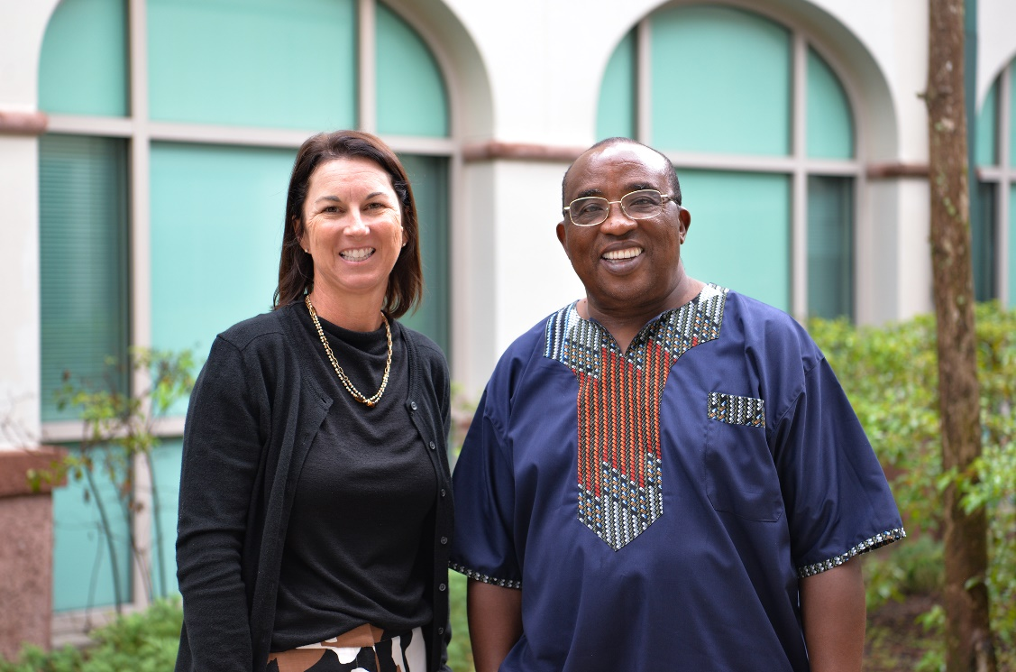

Name | Specialization | Office | Phone | Email
Tom Roberts, Ph.D. | Interim Dean, College of Education | MH 250 | 590-7806 | Troberts@fgcu.edu
Fenwick English, Ph.D. | Associate Dean, College of Education | MH 290 | 745-4680 | Fenglish@fgcu.edu
Keiana Desmore, Ed.D | Assistant Dean, College of Education | MH 247 | 590-7759 | kdesmore@fgcu.edu
Peter Ndiang’ui, Ed.D | Assistant Professor, CYS Program Coordinator | MH 254 | 745-4533 | pndiangui@fgcu.edu
Elizabeth  Reynolds | CYS Faculty and Internship Coordinator | MH 268 | TBD | Ewreynolds@fgcu.edu
Tracy Fragassi | Administrative Assistant | MH 241B | 590-7797 | Tfragass@fgcu.edu
Veronica DeLeon | Administrative Specialist | MH 241A | 745-4529 | vdeleon@fgcu.edu
George Williams | Director, COE Advising | MH 248 | 590-7676 | Gwilliams@fgcu.edu

What is a High-Quality Professional?

The conceptual framework for the College of Education at Florida Gulf Coast University is based upon the mission of preparing students for responsible citizenship, productive careers, and to be the learners and leaders of today and tomorrow. As learners, our graduates will continue to grow and develop as leaders within their field. As leaders, they will build upon the diverse backgrounds and perspectives they encounter to ensure that all individuals are able to construct the understanding necessary to become successful. During field experiences, students are assessed in domains related to the values and behaviors specified by the College of Education. These domains are connected to the strategic directions of the College of Education where we seek to create innovations in learning, engage the world and focus on those we serve.

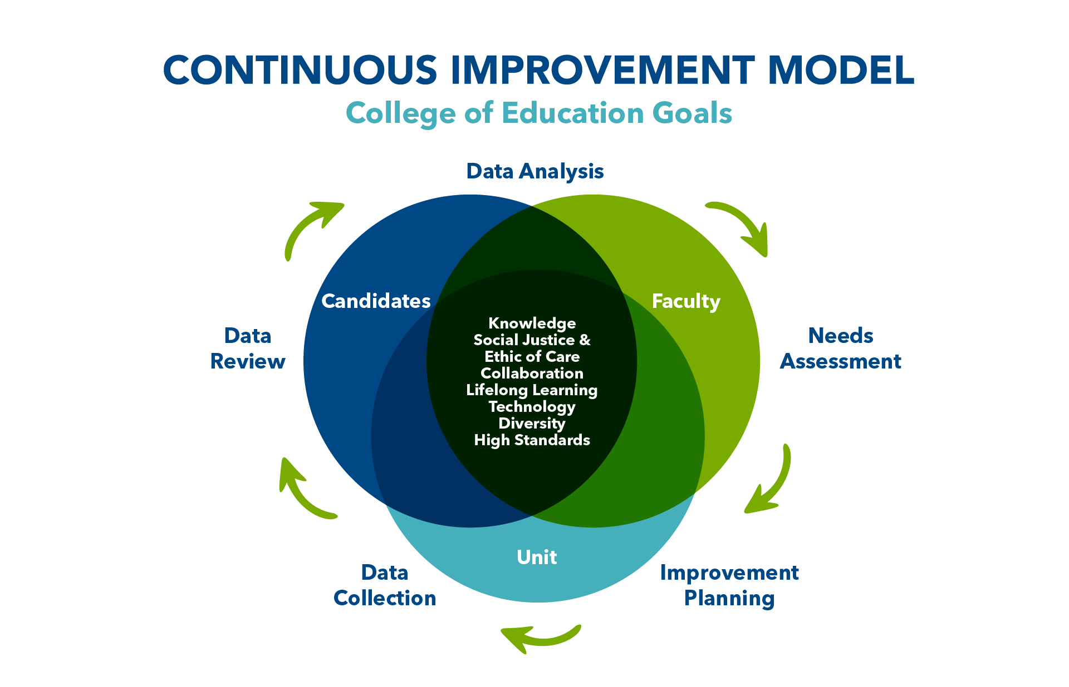

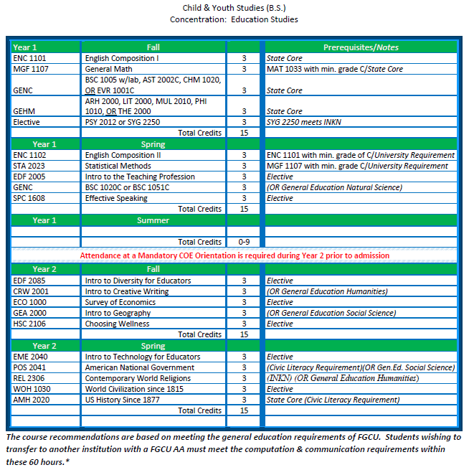
•See approved comse listing from tbe general education checklist intbe FGCU Catalog: httpih:Vl\t-w.fgcn.edu/Catalog/genedreq.asp After registration, check your Degreelvorks audit to ensme the course schedule meets the intended requirement
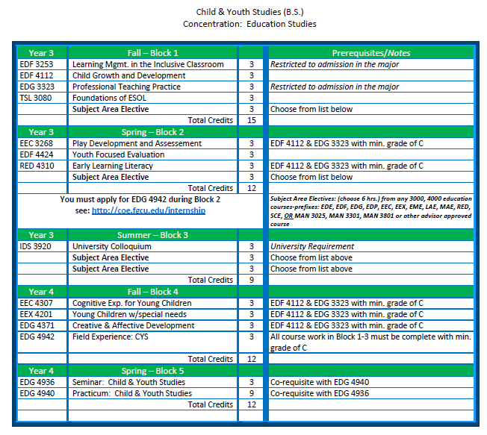

Program Admission is required before Block 1(Fall Semester-Year 3) the application process and paperwork is available at your mandatory COE Orientation.

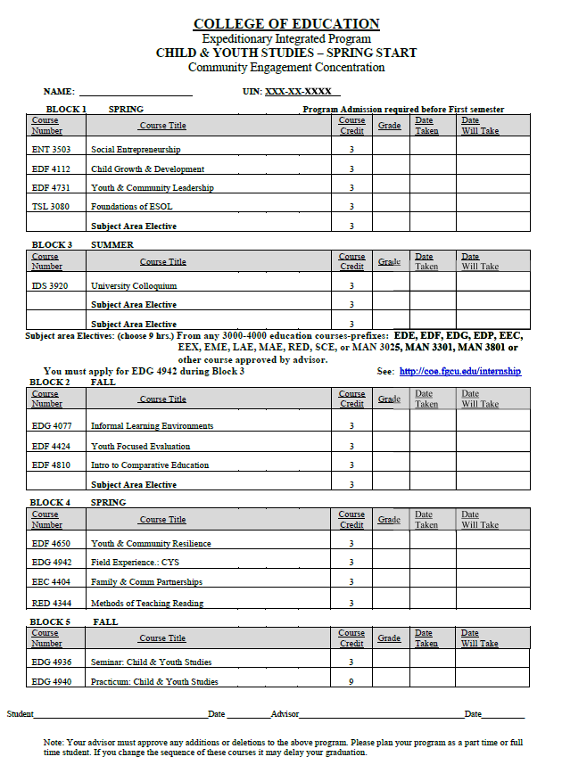

CYS Internship (Field Experience & Practicum)

Background

In CYS, an internship is a two-semester long mutually beneficial relationship between a student and a selected agency. In both semesters, students gain valuable hands-on experience in their CYS fields of study while earning academic credits.

The Field Experiences and Practicum in the CYS Program at Florida Gulf Coast University are two separate one-semester internship experiences that occur during two periods in the student’s program, one prior to their final semester, the “Field Experience” and one during the end of a student’s senior year, which is the “Practicum”. These two experiences are often referred to as “Internships”.

During the semester long “Field Experience” program (Level I internship), each candidate will be placed at a site, where they log 160 hours of work. During the semester long student “Practicum” (Level II internship) each candidate will be placed at a site, where they log 320 hours of work. In both cases, the student is expected to report regularly to an assigned site. The dates and times of the internship are mutually agreed by the student, site supervisor and university supervisor. In order to ease their load in the second part of the internship, students may roll-over a maximum of 100 hours from Field Experience to Practicum.

Guidelines for Placement of Student Field Experience

The College of Education’s Conceptual Framework explicitly values diversity in student preparation. Candidates are required to participate in field experiences that may include individuals with exceptionalities and individuals from diverse backgrounds, including ethnic, racial, gender, linguistic, and socioeconomic diversity. The CYS program coordinator works with our partners to identify high-performing, safe, stable, supportive, and collegial environments in which candidates can perform the duties of an internship.
University policy requires that candidates with disabilities be provided reasonable accommodations to ensure their equal access to course content. If a candidate has a documented disability and requires accommodations, he/she must inform the CYS Program Coordinator or designee at the time of application for field experience so that an appropriate placement can be secured.

Benefits of Internships

Internships enable students to perform meaningful work in the discipline of their choosing, gaining experience that can prove valuable upon graduation. They also allow both the student and the employer to see how compatible they are before committing to a full-time position. Internships serve as great recruiting tools for full-time jobs and provide employers with staffing for special projects that full-time staff may not have time to tackle. Interns also provide full-time staff with an opportunity to gain supervisory experience while the interns gain valuable experience working for a variety of supervisors.

Internship Compensation

CYS internships may be paid or unpaid. Paid internships are on a selection process and are an agreement between the internship and the university. You cannot, however, work at your job and be paid for an internship at the same time.

Types of Internship Experiences

Internship experiences should enhance a student’s learning of child and youth development. Types of experiences that qualify for internship approval are:

- Assisting a teacher in a preschool or VPK classroom

- Working with children or adolescents with developmental disabilities in an Applied Behavioral Analysis clinic, or other related environments

- Providing support services for children and adolescents

- Creating programs for the betterment of the community

- Assisting in the administration of resources to various community agencies

If an agency seeks an intern to do work other than that specifically related to child and youth development (such as exclusively filing papers or completing general office clerical or administrative work), it will not be selected as an eligible site because the experience does not align with the goals of the internship.

Internship Learning Outcomes

Upon completion of the internship, students will:

- Participate in a work environment reflective of today's diverse society

- Integrate academic theory with workplace practice

- Analyze realistic problems associated with the workplace and be given an opportunity to resolve these problems

- Demonstrate appropriate workplace ethics and personal behavior patterns

- Apply written and verbal communication skills within all appropriate levels of the organization setting

- Integrate a variety of professional experiences, job-seeking, and networking skills

Reflective Practice

CYS Internship is not just about providing services. It is a reflective process. As in other aspects of professional educators, interns encounter multiple and diverse experiences on a daily basis for which there are no easy answers. These experiences help the intern to grow. Reflection of these experiences is an important component of the internship. All professional educators need to develop the ability to identify and understand problems of practice, hypothesize alternative solutions, place new actions into practice, and evaluate the results of their teaching/activities. This cannot be achieved without applying the process of reflection as the ability to reflect on one’s professional practice is an important step in professional growth.
Reflection requires that each professional deeply examine an action as well as its result and analyze areas in which improvement needs to be made. Reflection requires a plan of action for improvement.

Throughout their coursework and field experiences, students have encountered and applied the concepts of inquiry, and reflection, and, to some extent, participated in reflective thinking. All candidates will be required to build on their past experiences and to keep and submit a reflective journal during their student field experiences. The information below is meant to guide all candidates in their ability to deepen their reflective processes.

Guide to Writing a Reflection:

Description

The description should emphasize the following: who, what, where, how and what next? This portion provides the background information for the audience. The description is simply accurate information with no editorial comments, opinions or conclusions.

Analysis

The writer analyzes the evidence looking for patterns, strengths and areas on which to improve. To be thoughtful the writer must provide an honest analysis of their strengths and weaknesses. Ask why did this happen and explain the underlying causes. An important element to the analysis is the citation of sources, articles, or classes where you learned about best practices, this provides insight as to why what you experienced, or saw does not fit with what you know.

Initial Planning

This is the rationale for reflection. The candidate must address how he or she will use the information to improve practice; it emphasizes the positive change in the candidate’s behavior and the expected impact on student learning.

Action

Your action plan should be described in detail and specifically tell how this plan will lead to change and growth for the candidate and their clients.

Culminating research-based project

During their internship, students are expected to conduct research as they work. The project should include the following sections: statement of the problem, research questions, objectives, hypotheses, literature review, data collection and analysis, findings and conclusion. During the Field Experience semester, students will be required a proposal of their research project. The complete project will be submitted during the Practicum semester. Details on how to write your final project will be explained during the orientation and in one seminar.

Selecting an Internship

All community partners that wish to host CYS interns must enter a legal agreement with Florida Gulf Coast University. The process for establishing the agreement is available through the FGCU Office of Internships and Cooperative Programs.

Examples of community partners that host CYS interns include but are not limited to…

- FGCU Wings of Hope
- FGCU Family Resource Center
- ABA Results Applied Behavior Analysis clinic
- Oasis Youth Shelter
- Golisano C’mon Children’s Museum
- Imaginarium Hands-On Museum
- Community School of Lehigh Acres
- IMPACT for Developmental Education
- Grace Place for Children and Families
- Lee Memorial Child Development Centers
- Harlem Heights Community Charter School
- Boys and Girls Clubs
- Sports CLUB Naples
- Quality Life Center of Southwest Florida
- Creative World School

Application and Placement Procedure

The Student Practicum and Field Experience in the CYS Program at Florida Gulf Coast University is a two-semester experience that occurs during a student’s senior year. During the 15-week student Field Experience (Level I internship) each candidate will be placed at a site for 160 hours.

During the 15-week student Final Practicum (Level II internship) each candidate will be placed at a site for 320 hours per semester.

The semester prior to entering Student Field Experience or Practicum, each candidate who meets the eligibility requirements will apply for the internship through the website. All coursework must be completed with a minimum GPA of 2.0, and the dispositional standards must be satisfactory.

The Field Experience link on the COE Website contains complete directions for the completion of this process. It is the responsibility of each candidate to become familiar with this process and complete it within the designated deadlines.

Semester of Internship | Application Deadline
Spring Semester | September 15
Summer Term | February 15
Fall Semester | February 15

The CYS Program Coordinator and Field Experience Coordinator will work with students to help identify an appropriate internship for the candidate’s area of interest. Once a potential site is identified, students are responsible for sending a cover letter and resume to the site supervisor so that arrangements can be made to meet and discuss the internship opportunities and responsibilities. This will include obtaining the necessary fingerprinting and background checks as required by the specific agency you are placed in. Candidates are responsible for all transportation arrangements.
Block 4 Field Experience and Block 5 Practicum Placement Process

- Intro - CYS Majors may be placed for internship (Field Experience or Practicum) in a community-based agency approved by COE through the program Coordinator
- Information about placement opportunities - A comprehensive list of approved partner agencies placement opportunities is made available to students as soon as they register to start their Block 4. The list of agencies and their brief descriptions is available under Files in the CYS COMMUNITY GROUP in Canvas. This list is not exhaustive and students may select other agencies. Such agencies must be approved by the faculty in charge of field placements
- Application - Eligible Block 4 students and those joining Block 5 initiate the application process by completing this form: https://fgcu.formstack.com/forms/student_teaching
- Selection of placement - The applicant selects three sites and provides some info that help in the processing. This application is submitted through the administrative office
- Matrix – The administrator in charge uses the information from the application process to create a matrix that includes the pertinent information
- Scrutiny – The CYS Program Leader or other designated nominee goes through the information provided in the matrix to determine the most suitable placement for each student. This will involve checking with the selected agencies on whether they are available to accept the intern
- Communication with applicant – Once a suitable placement is determined, the program leader communicates the same to the student and requests for feedback on whether the selected agency is acceptable to the applicant or not. This often involve some meetings and other forms of communication with the student.
- Acceptance of placement - Students are requested to indicate their acceptance of placement or request for change (with reasons) in a Canvas Assignment. The instructor in charge will communicate if a change is accepted or not – with reasons
- Finalization of placement – After an agreement between the student, the site supervisor and the CYS Program Leader is reached this is communicated to the university supervisor who will be working with the student
- Affidavit - An affidavit of the agreement is then signed by both the student and the site supervisor

Additional requirements for a CYS Placement as a Classroom Teacher in a K-12 setting for Blocks 4/5
In addition to the above steps, there are other additional requirements for CYS Education Studies Concentration Majors who wish to be placed in a classroom. Like students in education majors, CYS Majors interested in pursuing a teaching certification must complete the SAE requirement prior to their Block 4 placement to be placed in a K-12 school setting. This info will be communicated to the COE office of field and clinical experiences. Please note that you can take SAE in any subject area including those that do not require a specific degree. The placement internship will match the SAE. In order to be placed in a school setting, the following criteria must be complied with:

- Follow the Educational Studies curriculum as outlined in the program of study
- Select, take, and pass any Subject Area Exam (SAE) listed on FLDOE certification website for FTCE – Placement in a school must match the SAE BUT no other FTCE requirement)
- A grade point average of 2.5 or better in professional education and subject area courses
- Students already employed with a school district, charter school or an approved may be able to complete their CYS Block 4 Field Experience in their venue of employment with prior approval from both the employer and the College of Education.
- A CYS student may not progress to Block 5 if the SAE hasn’t been completely passed by the set deadline. Instead, an alternative placement will be provided (a community agency, or a paraprofessional or a preschool setting.

Fingerprinting:

Candidates may be required to be fingerprinted prior to beginning their student field experience. Information concerning this component should be requested from the site supervisor during the visit and prior to beginning the field experience.

Professionalism and Ethical Conduct During Student Field Experience

Conduct:

While participating in the field experience, candidates should consider themselves to be pre-service professionals and should conduct themselves in a professional manner in and out of all professional settings. The candidate agrees to follow the policies of each field site as well as the Codes of Conduct set forth by Florida Gulf Coast University and Florida DOE documents. The candidate agrees to follow the rules of each site as well as University policies.

Upon arriving at the site, the candidate should immediately become familiar with site policies. Candidates should view the student experience as an opportunity to demonstrate what they can do as a professional. Actions and words should be carefully considered as they will impact the candidate evaluation and written recommendations given by the Site Supervisor and the University Supervisor. Candidates demonstrating behaviors and dispositions unbefitting a professional may be subject to termination of their field experience.

Confidentiality:

The site supervisor and any individuals the candidate may come in contact with along with the site within which each candidate is placed have an expectation of total and complete confidentiality.
Depending on the nature of work at the candidate’s internship site, HIPPA regulations may be in effect. Health Insurance Portability and Accountability (HIPPA) is a federal law that requires the creation of national standards to protect sensitive patient health information from being disclosed. If applicable, it is the responsibility of the candidate to abide by HIPPA regulations. Realizing the legal, professional, and personal importance of confidentiality to the profession is a necessary disposition for all candidates. The expectation of all stakeholders is that the candidates apply and practice this disposition on a daily basis.

Attendance:

Candidates are expected to report to their assigned site either 200 or 400 hours per semester. Attendance at any type of staff meetings, parent meetings, conferences, and professional development days is highly recommended. Candidates should seek permission from their site supervisor to attend such meetings. Professional obligations may require the candidate to work beyond the scheduled workday. There are no excused absences during the student field experience and any days missed due to illness, bereavement, and other special situations must be made up.

In case of illness or emergency, the candidate must contact the site supervisor immediately, and the university supervisor must be notified, whether an observation is planned or not. Any illness in excess of three consecutive days must be documented by a written excuse from a doctor. In cases of prolonged or repeated absence, the site supervisor, university supervisor, and the Student/Internship Office will collaborate to determine whether the candidate’s experience will be terminated or extended.

Outside Commitments:

Student field experience is a full-time commitment. It is expected that other commitments and obligations be reduced to a minimum during this time. Candidates’ fieldwork duties must be given first priority, even when there may be other personally compelling concerns. The candidate is required to follow the calendar of the site where they are assigned. Work, family, or personal commitments cannot be excuses for failing to meet the commitments of the field experience and professional seminars. If such interference occurs, the candidate will be given the choice of withdrawing from the student field experience or making the personal adjustments necessary to give full attention to the program.

Corporal Punishment:

Candidates are never to administer corporal punishment as a means of discipline. Florida Gulf Coast University does not, under any circumstances, condone the use of corporal punishment. If a candidate chooses to engage in corporal punishment while at their placement, a corrective intervention will be put into place. Repeated offenses may result in the removal of a candidate from their internship placement.

Fingerprinting:

Candidates may be required to be fingerprinted prior to beginning their student field experience. Information concerning this component should be requested from the site supervisor during the visit prior to beginning the field experience.
Professional Attire:

The attire of the candidate should conform to the accepted dress code of the profession and the site where they are placed. It is the responsibility of the candidate to ascertain the dress codes of individual sites.
The chart below gives College guidelines for professional attire, but individual sites may have other regulations.
Suggested Attire- Women | Suggested Attire - Men
Skirts: Knee-length or longer | Shirt, tie and dress pants (Day 1).
Dresses- Knee-length or longer, NO spaghetti strap dresses. | Sport coat or blazer (not necessary unless mandated by school)
Non-denim casual slacks-Dockers/Khaki pants | Non-denim casual slacks-Dockers, Khaki
Dress Pants/Pant Suits | Polo type shirts
Dress Blouses, sweaters, and jackets- not  see through, mesh, tank tops, halter tops | Short sleeve button-down shirts, long sleeve dress shirts.
Dress turtlenecks/banded collar shirts/crewnecks- non-T-shirt material. No  T-shirts. Shirts, and dresses must not expose cleavage. | Dress turtlenecks/sweaters/banded collar shirts/crewnecks- NO T-shirts or T-shirt material or shirts with logos or slogans.
Dress or casual shoes, NO flip flops, crocs, beach shoes or stiletto heels. | Dress or casual shoes, NO flip flops, crocs, beach shoes. Socks must be worn.
Body piercing jewelry - ears only | Body piercing jewelry- none
No visible tattoos | No visible tattoos

Observations

Interns will be observed by both the university supervisor and the site supervisor three times in a semester. This can be done virtually or face-to-face. Observation One will be conducted during the first two weeks of the internship. Observation Two will be done either during the week before or the week after the mid-term break. Observation three will be done during the last two weeks of the semester. Each observation will be documented by the university supervisor. The student will be required to write a reflection of the learning experience after each observation. After the final observation, the site supervisor will be required to complete the Disposition Assessment Form.

Roles and Responsibilities of Students, Site Supervisor, and University Supervisor

The entire program is directed by the Program Coordinator assisted by the faculty assigned to different CYS courses. The coordinator and faculty serve as instructors in charge of the various Canvas courses including the field experience, practicum and seminar. There are also university supervisors who are assigned a number of interning students. While they are in the field, interns work under the supervision and guidance of a site supervisor. Supervisors represent a crucial point in the candidates’ preparations to becoming professionals. It is a time when theory and practice meet and when candidates may discover whether they even want to work in their chosen profession. The traditional model of clinical practice consists of a triad of the candidate, the University supervisor and the site supervisor. Each of these members make unique contributions to the internship process. The focus of the university supervisor is primarily on the candidate and how they are fulfilling the college program’s expectations.

The Site Supervisor is focused on how the candidate is functioning at the site and how the candidate supports client learning and development. The site Director provides insight into the connection between national, state, and local program goals and how these are integrated with practices at the site. Candidates should be focused on their impact on client learning and their professional development.
All parties of the triad – student/candidate, university supervisor, site supervisor – share mutual responsibility for the development of the candidates’ efficacy concerning their practice and their ability to deliver strong instructional practice. The candidate’s professional efficacy will be strengthened by a collaborative culture with rigorous expectations and proactive peer review which will focus on the candidate’s impact on client learning.
Specific Student/Candidate Responsibilities of the Field Experience Student:

Candidates are novice professionals and reflective learners who must realize and fulfill the responsibilities of both roles. Candidates must follow the same policies and expectations as licensed or experienced professionals; they are to be guided by the site supervisor who must provide clear directions and closely monitor their behaviors in these areas.

Prior to the First Day of the Internship, Each Candidate Must:

- Review the website of their assigned site.
- Read and become familiar with any Practicum Site Handbook and make note of sign-in procedures and starting times.
- Locate the site Calendar and mark important dates in their personal calendar to facilitate their involvement in the full range of instructional and professional activities.
- Locate the site and determine at least 2 driving routes.
- Call the site or email the site supervisor to set up an appointment for you to visit the site prior to the beginning of the semester
- Read the Course Syllabus which will be located on Canvas.

During the Field Experience, Each Candidate Must:

- Begin the experience by attending the appropriate orientation session.
- Conduct himself/herself in a professional manner at all times, including dress, speech, and personal habits such as punctuality and preparedness.
- Give the field experience first priority over competing concerns.
- Be punctual in arriving at the site, seminars, and meetings.
- Notify the site supervisor and university supervisor as early as possible of absences or tardiness.
- Become acquainted with and abide by site policies.
- Show an interest and initiative in assuming the increasing responsibilities of the agency field experience position.
- Demonstrate practice that integrates technology and differentiated instruction.
- Reflect and analyze the impact of their instructional practice on client or student learning gains.
- Demonstrate effective site/client management skills.
- Communicate with the site supervisor and university supervisor in order to keep both informed about progress, problems, or other issues which might impact their development.
- Attend site functions such as IEP meetings, Client observations, Open houses, parent conferences, professional development opportunities, etc.
- Complete the requirements of the field experience including attending all seminars.
- Maintain client and professional confidentiality.

Responsibilities of the Site Supervisor

Florida Gulf Coast University appreciates the time and effort involved in fulfilling the complex role of the site supervisor. This role involves mentoring and evaluating the practice and dispositions of the candidate, but site supervisors will also fulfill a number of other roles: role model, guide, advisor, and colleague. Some of the most important roles involve initiating the candidate into the professional and established norms of the professional and site culture, sharing your wisdom and expertise, and respecting and encouraging innovations. Remember, this is a new situation for the candidate, he/she might not have a sense of what to expect or where he/she will fit into the “scheme of things.” Do not assume that the candidate has background knowledge specific to your site or situation; by being specific in your directions and expectations you and the candidate will experience less anxiety.

Consider working with the student as a co-leader; plan and teach lessons/activities as a team embracing the Gradual Release of Responsibility paradigm for most of the candidate experience. Co-planning and co-teaching are effective ways to model sound techniques and better guarantee a quality experience for all. As you prepare to assume this role, the Internship Office hopes you find this list of expectations helpful.

The site supervisor is expected to:

- Demonstrate a positive attitude towards all learners and a belief that all students can learn.
- Prepare your clients, students, and families for the arrival of the candidate.
- Model professionalism through appearance and relationships with colleagues.
- Maintain open communication with the candidate and the university supervisor.
- Define expectations in a reasonable and clear manner and establish an atmosphere of mutual trust and respect which will lead to a strong collaborative partnership.
- Provide opportunities for the candidate to interact with families and the community in meaningful ways.
- Explain the role of all site personnel to the candidate and how each supports the classroom community; facilitate introductions to site personnel.
- Provide the candidate with appropriate books and reference materials for review and use.
- Provide the emergency and safety plan to the candidate.
- Identify health issues of any client - allergies, diabetes, epilepsy etc.
- Provide candidate information about attendance, policies and procedures.
- Exchange contact information with the candidate and a procedure to follow if the candidate is absent.
- Share and demonstrate ways to meet the needs of diverse learners.
- Preview and observe lessons/activities and provide constructive feedback on a daily basis.
- Help the candidate focus on their impact on client learning as well as on their own professional development.
- Assist the candidate in maintaining a site management plan.
- Attend the three observations
- Meet with the university supervisor and the candidate to complete assessment instruments and to resolve issues relating to the experience.
- Complete all evaluation forms in collaboration with the university supervisor and the candidate.
- Sign and return all contracts to the university.

Responsibilities of the University Supervisor

The major roles of the University Supervisor are to be a facilitator in the student/candidate field experience and to act as a liaison between the school and the University. These roles share the same complexity as that of the site supervisor in that the University Supervisor is both an advocate and evaluator for the candidate. Although the supervision of the candidate is a joint responsibility, University Supervisors must meet with both the candidate and the site supervisor on a regular basis to ensure the efficacy of the program and the candidate’s progress. University Supervisors will make at least five observations at regular intervals throughout the semester and provide formative feedback and suggestions for improvement. They may also make unannounced visits and observations during the semester. Supervisors must also plan and conduct three seminars.

The University Supervisors are expected to:

- Attend the University Orientation/Training Meeting for University Supervisors.
- Conduct an orientation session no later than the end of the first week of the experience with the site supervisor, candidate, and site director (if possible). Discuss all evaluation forms, procedures, and expectations of the student field experience.
- Provide the Student Field Experience Handbook to the site supervisor.
- Develop and maintain a personal file for each candidate. Keep a schedule for observations and try to vary the time and day you observe.
- Attend the Student Orientation meeting which will be held during the first week of each semester.
- Plan, schedule, and deliver three seminars with assigned candidates.
- Schedule a minimum of three observation visits and provide specific, constructive feedback orally and in writing to document the progress of the candidate.
- Confer with the candidate following each observation. A pre-observation conference is suggested; a post-observation conference is required.
- Obtain the signature of the student on all observation forms.
- Confer with the site supervisor at each observation visit.
- Organize and attend the three observations either virtually or face-to-face.
- Be available to the student and site supervisor whenever support is needed.
- Provide timely responses to professional problems, including inadequate performance and inappropriate behavior by the candidate.
- Communicate with the Internship Office when problems arise, co-write a Professional Development Plan when necessary, and provide information to the University to help resolve problems with the candidate.
- Complete assessment forms and surveys by established deadlines and turn all forms into the Internship Office along with the candidate’s grade.

Procedure to Follow if Problems Arise During the Field Experience/Practicum

The admission standards to the student t field experiences serve as an attempt to place only those candidates who have a reasonable chance of successfully completing the field experience. All parties must keep in mind that candidates are novice practitioners with unique strengths and insights into the process. With that reality in mind, the College of Education will support the candidate and serve as a resource; however, the candidate must realize that placement does not guarantee completion. Many practicum sites do not allow for an intervention plan and may remove the candidate immediately from the site without prior notice. Successful completion of the student field experience is the responsibility of each candidate.

When an issue impacting the successful completion arises the Student has the following responsibilities:

- Immediately discuss any specific concerns with the Site Supervisor and University Supervisor.
- Be an active listener and communicator.
- If Intervention is necessary, work to overcome any weaknesses and follow an intervention plan if appropriate. Many practicum sites do not allow for an intervention plan and thus the candidate may be removed immediately from the practicum site without notice.

The Site Supervisor has the following responsibilities:

- Clearly communicate any concerns to the candidate and the University Supervisor immediately.
- Develop an Intervention Plan, if appropriate, with the University Supervisor and the Candidate as soon as major concerns are identified.
- Inform and/or involve the Office of Student/Clinical Experience in the process.
- Provide specific feedback to the Candidate and University Supervisor.
- Document any concerns, interventions, and progress of the candidate.

The University Supervisor has the following responsibilities:

- Communicate with the Site Supervisor about any concerns.
- Develop an Intervention Plan, if appropriate, with the Site Supervisor and Candidate.
- Inform/Involve the Office of Student/Clinical Experience in the process.
- Provide written documentation about any concerns, interventions, and progress.
- The Site Director has the following responsibilities:
- Communicate with the Site Supervisor/report any problems.
- Communicate with the University Supervisor or the Office of Student/Clinical Experience if any problems are not resolved.
- Provide written documentation and/or recommendation of removal. The site must document to the University any issues with the candidate prior to dismissal.
- The Office of Student/ Internship has the following responsibilities:
- Collaborate with the Educational Team and collaborate in the development of a remediation plan.
- Observe Candidates when necessary.
- Follow up with the Educational Team concerning the progress of the Candidate.
- When necessary, remove the Candidate from placement.

Policy on Intervention and/or Removal During the Practicum/Field Experience

The purpose of the Student Intervention Plan is to formalize support for a Candidate that is focused on areas that need improvement. Prior to developing a plan, the University Supervisor and Site Supervisor should informally mentor and support the efforts of the Candidate.

At approximately four weeks into the final Practicum, the University Supervisor, in collaboration with the Site Supervisor will assess the Candidate’s demonstration of sufficient mastery of skills and professional attitudes necessary for taking full site responsibility. Satisfactory performance is mandatory in all areas of evaluation. Any area noted as “needs improvement” will require intervention. The team may generate a Candidate Intervention Plan coordinated by the University and Site Supervisors along with the candidate.
The team, in a planned meeting, will share the plan with the Candidate. The plan will specify an Intervention Plan of action with a timeline for its completion and recommended support for the Candidate. In some cases, a practicum/field experience site will not allow the candidate to continue and will call for immediate removal and the University must comply with their request.

The format for the development plan can be found in the Appendices or on the COE website using the Field Experiences Link. It includes an overview of the current status of the Candidate’s progress, strengths, specific concerns, plan of action, support needed, and date to reconvene the team to review the progress.
A follow-up meeting is held within two weeks to determine if necessary, skills and professional attitudes are in place for the intern to take full site responsibility. If sufficient mastery of skills and professional attitudes necessary for full takeover of responsibilities are evident, the candidate may continue in the current placement, extending the time in full takeover to meet internship requirements. The candidate is expected to earn a satisfactory grade.

If at that point, the skills and professional attitudes are not present, the team may recommend an incomplete grade for the Candidate followed by a meeting with the Internship Intensive Assistance Review Board (IIARB) to determine if the candidate’s repetition of the internship is merited. The IIARB membership will consist of the COE Department Chair for CYS, University Supervisor, and a COE Advisor.

Upon being recommended for Candidate repetition in the following fall or spring semester, an Intervention plan may be developed by the University Supervisor in cooperation with the Site Supervisor.

Intervention Guidelines and Removal of a Student from Practicum/Field Experience

If a new placement occurs, it will be in a different site, and a different University Supervisor may be assigned. The Intervention Plan is developed on a case-by-case assessment and will be tailored to the needs of each candidate. Candidates must adhere to intervention plans written for them.

If the Intervention Plan is completed satisfactorily during the repeated internship, the candidate will receive a grade of Satisfactory for the course. If the Intervention Plan is not completed satisfactorily and within the specified time schedule, the candidate is dismissed from the internship and removed permanently from the education program. If a candidate wishes to appeal the decision of the Internship Intensive Assistance Review Board, he/she may submit a request through regularly established channels for grade appeals at Florida Gulf Coast University.

Removal of a candidate:

The removal of a candidate from his/her placement will only be done for compelling reasons. In some cases, a practicum/field experience site will not allow the student to continue and will call for immediate removal and the University must comply with their request. The Office of Student/Clinical Experience recognizes that there may be circumstances that may warrant removal and will consider requests to remove a Candidate when any of the following situations occur:

- Unethical behavior has been exhibited by either the Student or the Site supervisor (i.e., sexual harassment, use of alcohol or drugs).
- Any evidence of a lack of sensitivity to multicultural situations on the part of the student.
- Excessive absenteeism, tardiness, and or failure to comply with established site policies on the part of the candidate.
- The appropriate site authority or the administrator, requests that the candidate be removed.

All requests for the removal of a candidate should be made through Florida Gulf Coast University’s Office of Student/Internship. Written documentation must accompany any request for removal. If a candidate is removed from their site, the candidate will repeat the complete student experience the next available semester in an agency different from the one from which they were removed. Students removed from their student experience may be subject to discipline through the University Student Conduct Office and possible dismissal from the University.

Criteria for a Passing Grade: Student Practicum /Field Experience

Candidates who satisfactorily complete all student field experience and practicum components are awarded a Satisfactory (S) grade. Evidence of successful completion may include completion of the required number of hours (160 for Field Experience and 320 for the Practicum), site supervisor assessments, satisfactory disposition assessment, completion of the critical task, other Canvas assignments and any other evaluations and/or rubrics given by the course instructor. Evaluations must be within the required range that would indicate that the candidate has demonstrated readiness for assuming the responsibilities of their profession. ALL of the rubric scores on the Disposition Assessment Form must be in the Target or Acceptable range. Scores within this range indicate that the candidate has demonstrated acceptable dispositions for assuming the responsibilities of their profession. All evaluations must provide quantifiable evidence of growth.

All candidates who receive a grade of Satisfactory for student field experience, provided that all course work has been completed, become eligible for graduation from the Child and Youth Services program. All evaluation forms can be found in the Appendices of this handbook.

Receiving a Grade of Unsatisfactory

A Student whose performance is such that he/she cannot fulfill the duties normally expected of teachers will receive a grade of “unsatisfactory.” The grade will be supported by written documentation from the University Supervisor and the Site supervisor, documentation must include evaluation and assessment documents that indicate areas of concern or inability to fulfill the duties normally expected of students. Written documentation may include observational notes, letters of complaint, or legal documents.
Incomplete (I) Grade “Incomplete” (“I”) grades can be recorded only in exceptional cases. These occur when a student, who has completed a substantial portion of the course and who is otherwise passing, is unable to complete a well-defined portion of a course for reasons beyond the student’s control. Students in these circumstances must petition the instructor and should be prepared to present documentation that substantiates their case. “Incompletes” should not be granted in order to allow students to do extra coursework in an effort to increase their grades.

APPENDICES

Appendix A

Candidate Field Experience Checklist

In addition to applying for Student field experience, I have registered for all coursework associated with the Student field experience semester.
I have printed and read University Student Field Experience Handbook.
I have completed fingerprinting (if required by the site).
I have obtained Liability Insurance and printed 2 copies of confirmation of insurance.
I have contacted my site supervisor and made an appointment to visit the site prior to the beginning of the semester.
I have reviewed the site’s website (if there is one) and have done the following:

- Read site information and literature

- Marked important dates on the calendar

- Found two routes to the site.
I have visited the site prior to the beginning of the internship and obtained any pertinent materials from the Site Supervisor.
I have introduced myself to the site office staff and the director.
I have attended the University Orientation, arrived on time, and brought confirmation of insurance to orientation.
I have signed and submitted the Field Experience Handbook Agreement.

I have marked important dates in my personal calendar, including pertinent information including plan submission information, supervisor seminars and locations of seminars, and University Supervisor and Site supervisor contact information.
I have obtained the site Policy and Procedures Manual and read it to make myself familiar with policies, especially in regard to safety plans and health concerns.
I have become familiar with the materials supplied by my Site supervisor (maps, short- and long-range plans, site procedures, site management plan, etc.).

Appendix B
Site Supervisor Checklist

Before the Internship
I prepared my site for the arrival of “another employee” who will have the same authority as me.
I have arranged for a desk or some form of personal space for the student (desk, table, and chair).
I have welcomed my student’s call and have set up a meeting for them to visit the site prior to officially beginning.
I have met with the University Supervisor and read the material supplied by the University to provide background information about my candidate and the program components.
I have prepared/acquired a collection of pertinent information and material that my candidate will be working with.
I have exchanged personal contact information with the candidate.
I have developed a schedule for the candidate outlined with their locations and descriptions of duties.
Beginning of the Internship
I introduced the candidate to my co-workers, including the administration.
I have familiarized the candidate with the facilities, resources, and policies regarding the use of

materials and equipment.
I have explained the procedures for record-keeping/data collection.
I have provided time for the candidate to examine data from the records of clients they will be working with, sample lesson plans, and become familiar with the various services the site provides such as guidance, ESL, client support, library, media, etc.
I have informed the candidate of expectations concerning the submission of plans and how approval and feedback will be communicated.
I have discussed and developed expectations that conform to the University CYS program components.
During the Internship
I have helped the candidate develop plans for his or her site experiences.
I have helped the candidate identify specific competencies to strive to improve on an ongoing basis.
I have co-taught lessons (if applicable) with the candidate, gradually relinquishing teaching responsibilities.
I have observed the candidate closely and consistently during their activities and experiences to provide continuing, specific feedback and evaluation, including specific suggestions for improvement and specific praise for successes.
I have communicated openly with the candidate regarding professional issues and encouraged the student to evaluate his or her own plans and professional practice.

I have encouraged initiative and creativity on the part of the candidate.
I have conferred with the University Supervisor at each observation visit.
I have provided the candidate with some written evaluations of their performance.
I have provided opportunities for the candidate to observe other activities and other employees.

Appendix C
University Supervisor
Checklist

Before the Internship
I have attended the Orientation for University Supervisors, acquired a folder and evaluation forms for each student that I am assigned.
I have read the Student Field Experience Handbook.
I have made arrangements to have my fingerprints put on file at the site (If required).
I have explained the expectations of site observations and exchanged contact information with each candidate.
I have attended the initial Senior Seminar to meet the candidates I will be working with.
During the Internship
I have contacted each Site supervisor and made appointments with the candidate and supervisor to explain the program and its requirements during the first visit.
I have observed each candidate 3 times over the course of the semester. (Note: If necessary, more visits may be necessary with issues arise. Contact the program coordinator if this occurs.)
I have maintained a folder for each candidate with all forms completed and updated as necessary.

I have consulted with the Site Supervisor on each observation visit as needed.
If necessary, I have completed the mid-term evaluation and explained to the Site Supervisor any expectations not being met.
End of the Internship
I have executed the established procedure and date to complete the final evaluation with the site supervisor and student.
I have completed all evaluation forms, including all signatures.
I have placed all completed forms in each student’s folder and provided the student with a copy of the final evaluation.
I have created an alphabetical list of my students along with their grades. (S or U)
I have turned in all folders to the department along with the list of students’ grades by the end of the semester.

Appendix D

Highly Recommended: CYS Field Placement Observation Form
Date: | Candidate:
Location: | Observer:

Planning & Lesson Content
Did the candidate design learning experiences with objectives and outcomes that are developmentally appropriate for the learners?
Did the candidate take steps to make accommodations for diverse learners based on their cognitive abilities, ethnic backgrounds, socioeconomic backgrounds, etc.?
Did the candidate organize the appropriate resources necessary for the activity prior to the start of the activity?

Instruction & Assessment
Did the candidate begin the scheduled lesson on time? Was the lesson’s duration appropriate?
When speaking with their learners, did the candidate give clear instructions that cater to the needs of diverse types of learners?
At the completion of the activity, did the candidate review answers or target responses with the learners and respond with positive feedback?

Did the candidate utilize ongoing informal or any formal assessments?

Communication & Management
Did the candidate interact with their learners in a positive and effective manner?
Did the candidate communicate with their coworkers/peers in a manner that fostered effective collaboration?
Did the candidate use effective classroom/group/client management strategies when working with learners?

Notes/Feedback:

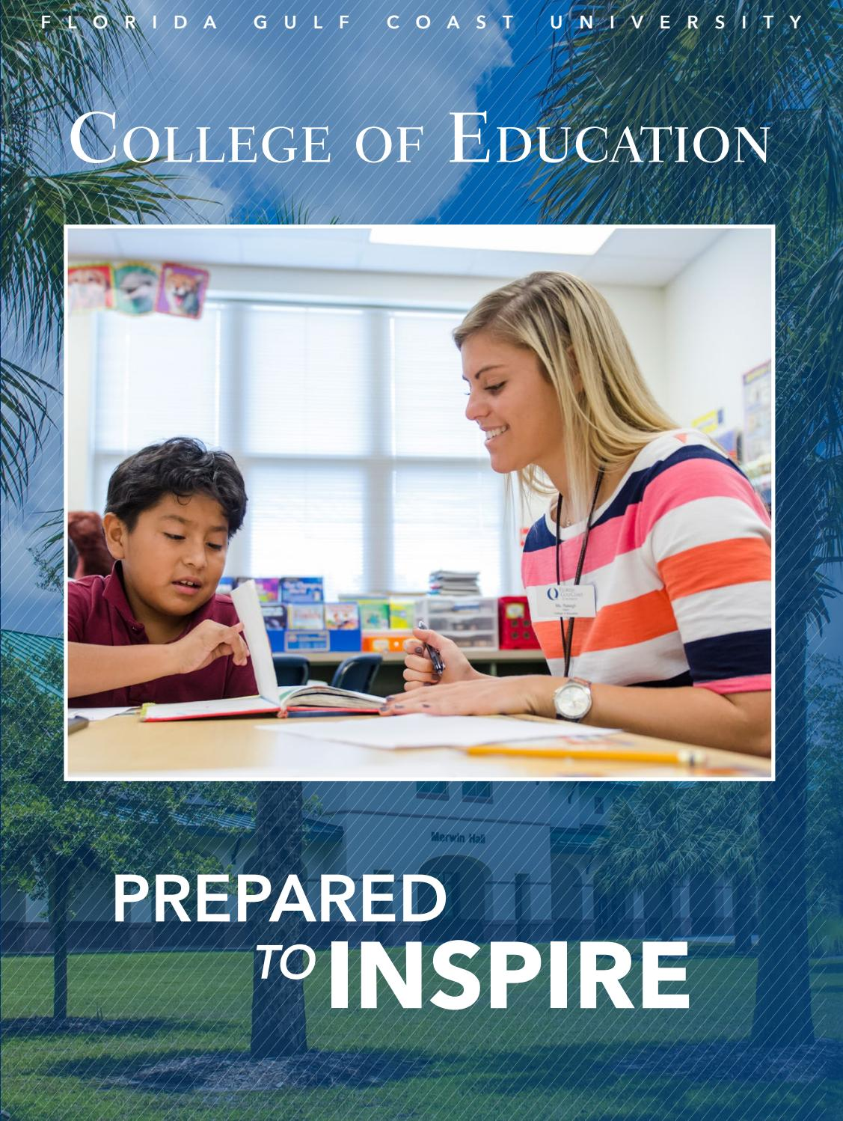
CYS FIRST OBSERVATION

CONDUCTED DURING THE SECOND OR THIRD WEEK OF THE INTERNSHIP
Date completed _____________________________
Name of Intern _____________________________________________________
Site _______________________________________________________________
Name of Site Supervisor _______________________________________________
Name of University Supervisor _________________________________________
Objectives:
- To provide an opportunity for the university supervisor, the site supervisor, and the interning student to get to know each other.
- To discuss the roles that the university and the site supervisor will be playing to support the student in succeeding at their internship.
- To understand from the site supervisor the rules and regulations of the internship site.
- To discuss the specific duties and responsibilities that the student intern will be completing throughout the semester.
- To go through the CYS Handbook and CYS Hours Logs and ensure that all parties involved have a clear understanding of what the internship entails.
- To sign the necessary documents included in the CYS Handbook.
- To address any questions or issues arising from the first week of the internship.
- To establish a schedule of activities for the entire semester to ensure that the time and content requirements will be met successfully.
- To schedule the second and third observation dates for the semester.
OBSERVATION FOCUS AREAS
The university supervisor may approach the following focus areas using their unique supervision style
The student intern and their site supervisor must address all questions with the university supervisor during this initial site observation:
- Address all the areas included in the objectives.
- Check scope of work – student internship schedule, areas of interest, work completed, responsibilities, hours logs.
- Overview of the daily work at a glance.
- Building connections/relationships etc.
- Discussion of focus of the mid-term observation – scope, date, content etc.
- Anything else important?
NOTES TAKEN BY THE UNIVERSITY SUPERVISOR DURING THE OBSERVATION

Targeted area where student candidate may need help/support/areas for improvement
_________________________________________________________________________________________________________________________________________________________________________________________________________
Anything else observed _________________________________________________________________________________________________________________________________________________________________________________________________________
Overall Recommendation ____________________________________________________________________________________________________________________________________________________________________________________________________________________________________________________________________________________________________________________________________________________________________________________________________________________________________________________________________________________

CYS SECOND OBSERVATION

CONDUCTED DURING THE MID-TERM WEEK OF THE SEMESTER
Date completed _____________________________
Name of Intern _____________________________________________________
Site _______________________________________________________________
Name of Site Supervisor _______________________________________________
Name of University Supervisor _________________________________________
Objectives:

- Conduct a mid-term evaluation of student progress made at internship site and make suggestions for improvement.
- Ensure that the student has done ample work as stipulated in their internship schedule.
- Address any questions by the student intern, site supervisor, and university supervisor, and provide the necessary support for the student intern.
- To discuss the requirements for student evaluation as stipulated in the CYS Disposition Assessment Form. Everyone will be given copies of the Disposition Assessment for the final observation.

OBSERVATION FOCUS AREAS
The university supervisor may approach the following focus areas using their unique supervision style
The student intern and their site supervisor must address all questions with the university supervisor during this second site observation:
- Address all areas identified in objectives.
- Review student hours logs and/or remind students to upload hours logs to canvas and have their site supervisor sign hours logs.
- Review student roles and responsibilities and how their duties are being accomplished.
- Discuss where student has made improvements since the beginning of the semester at site with student and site supervisor.
- Process challenges faced by the student as they’ve learned their responsibilities at their site.
- Discuss how they student has participated in team work and building relationships at internship site.
- Identify any other areas for improvement from the student and their site supervisor.
- Review CYS Disposition Assessment Form with student and their site supervisor. Explain to site supervisor that they must complete and sign form for final observation and that student will sign the form as well.
NOTES TAKEN BY THE UNIVERSITY SUPERVISOR DURING THE OBSERVATION

Targeted area where student candidate may need help/support/areas for improvement
_________________________________________________________________________________________________________________________________________________________________________________________________________
Anything else observed _________________________________________________________________________________________________________________________________________________________________________________________________________
Overall Recommendation ________________________________________________________________________________________________________________________________________________________________________________________________________________________________________________________________________________________________________________________________________________________________________________________________

CYS FINAL OBSERVATION

CONDUCTED DURING THE LAST TWO WEEKS OF THE SEMESTER
Date completed _____________________________
Name of Intern _____________________________________________________
Site _______________________________________________________________
Name of Site Supervisor _______________________________________________
Name of University Supervisor _________________________________________
Objectives:
- Conduct a final evaluation to find out if student has met responsibilities and hours requirements.
- To complete the CYS dispositions document together with the student and the site supervisor.
- To provide any last-minute support to ensure that the student is successful.
OBSERVATION FOCUS AREAS
The university supervisor may approach the following focus areas using their unique supervision style
The student intern and their site supervisor must address all questions with the university supervisor during this initial site observation:
- Final Evaluation- Review disposition form and discuss all areas and how student performed.
- Identify areas of support in order for the student to successfully complete the internship.
- Address all the areas included in the objectives.
NOTES TAKEN BY THE UNIVERSITY SUPERVISOR DURING THE OBSERVATION

- Has the internship been completed _____ or is on schedule _____?
- Has the student completed and site supervisor signed all hours logs?
- Is the completed disposition form satisfactory? _______
- Targeted area where candidate may need help/support/improve to satisfactorily complete the internship
________________________________________________________________________________________________________________________________________________________________________________________________________________________________________________________________________________________________________________________________________________________________________________________________

Overall Recommendation ________________________________________________________________________________________________________________________________________________________________________________________________

