# Directions for Scoring in Watermark Via

1. Proceed to [**www.vialivetext.com**](http://www.vialivetext.com)
2. Enter complete FGCU e-mail (See Figure 1.)
3. Click “Forgot Your Password?” to create a password for your account.
4. Click the Sign-in icon (See Figure 1.)

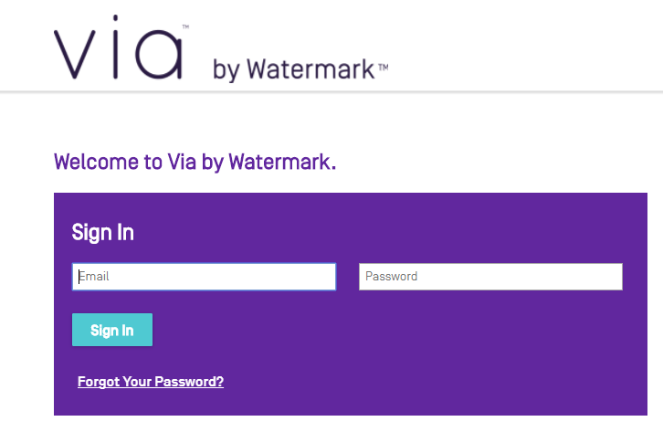

Figure 1. Watermark Via Login Page

1. In Progress courses and field experiences will be listed chronologically (See Figure 2.)
2. Click the title of the course or field experience to select (See Figure 2.)

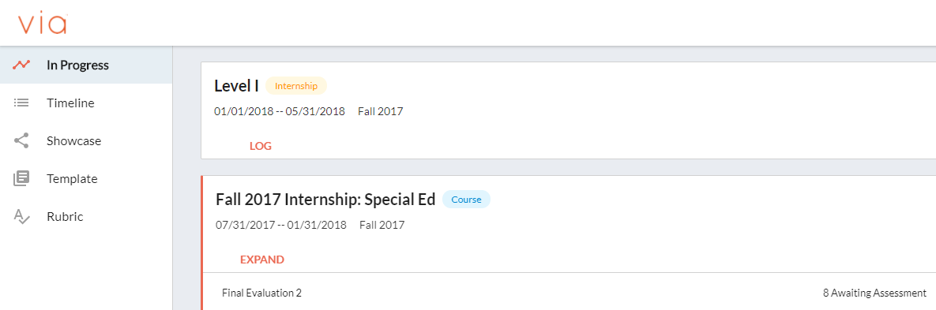

Figure 2. Via Dashboard

1. Assessments are shown in the activity section (See Figure 3.)
2. Click on the title of the activity (See Figure 3.)

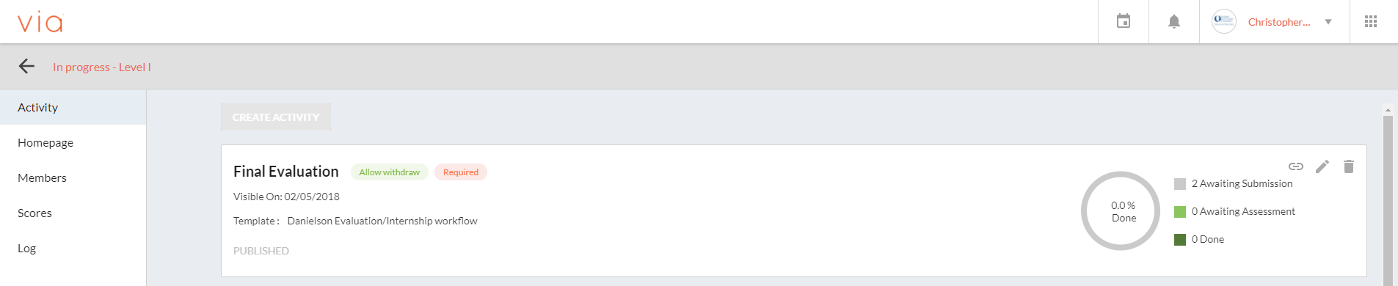

Figure 3. Activity Within a Via Course

1. The course roster is shown with submission status, those ready to be assessed are shown under *Awaiting Assessment* (See Figure 4.)

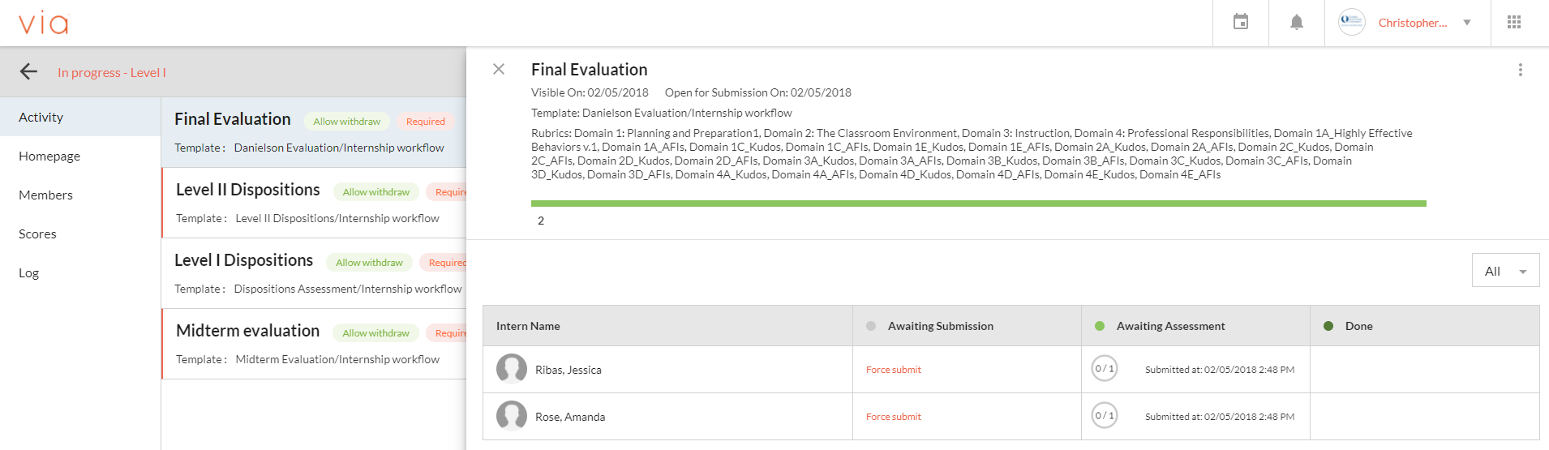

Stduent 1

Stduent 1

*Figure 4.* Course Roster Within Via

1. To grade a student, click on an individual name (See Figure 5.)

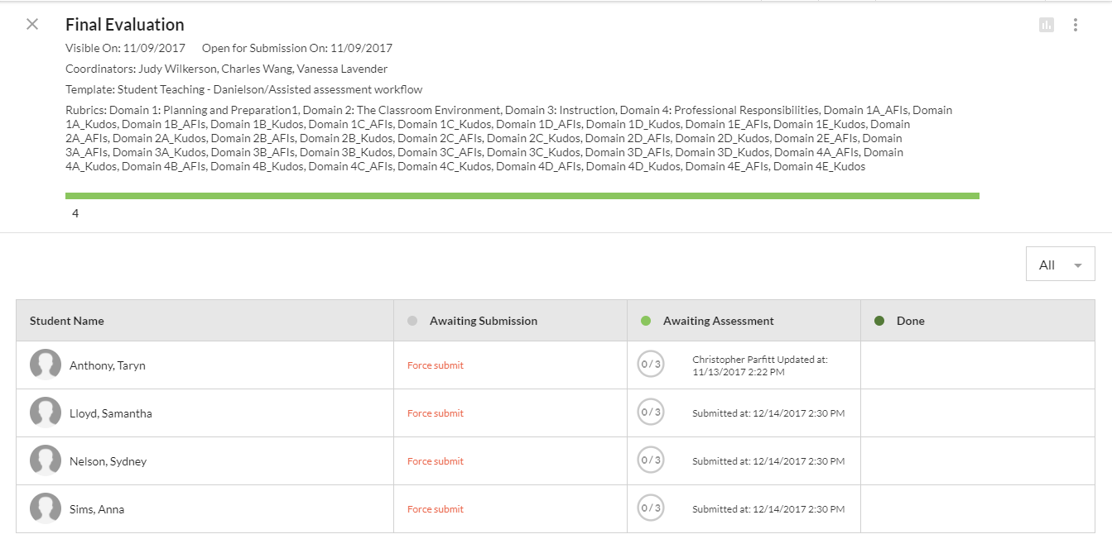

Student Name

Student Name

Student Name

Student Name

Figure 5. Student Roster for Activity

1. The evaluation template will open with an Assessment Panel in a small column to the right and a description in the center (See Figure 6.) If the assessment panel is hidden, click on the small double arrows (not always available) as shown in Figure 7.

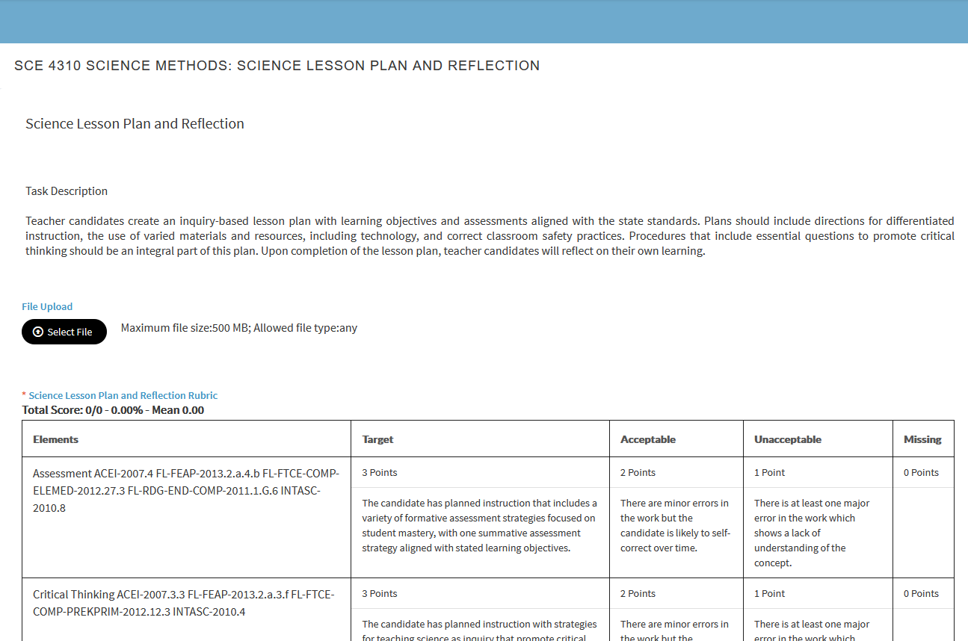

Figure 6. Assessment Ready for Scoring



Figure 7. Expansion Arrows (Option not always available)

1. Click on the column heading marked N/A to set the default rating for each section. Orange checkmarks show the selected rating (See Figure 8.), repeat for each new section

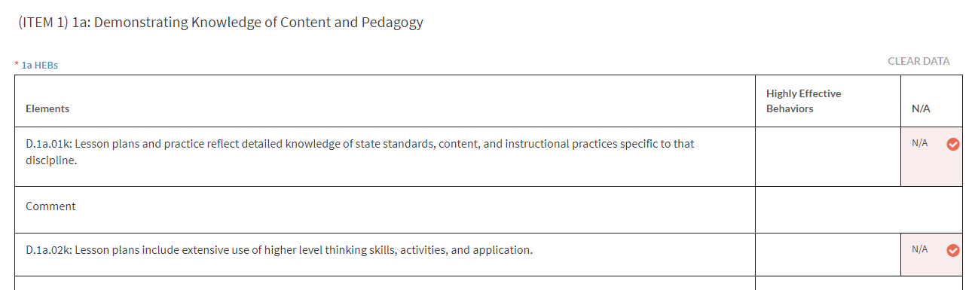

Figure 8. Setting N/A as the Default Rating

1. Click in a different box within a column to change a rating, also comments for specific indicators can be typed below (See Figure 9.)

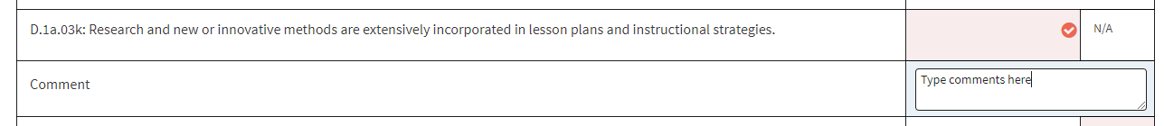

Figure 9. Changing Ratings

1. Once an item has been scored, use the parameters to select the appropriate proficiency for the corresponding item in the assessment panel. The box and checkmark will be colored orange to show a selected proficiency level (See Figure 10.)

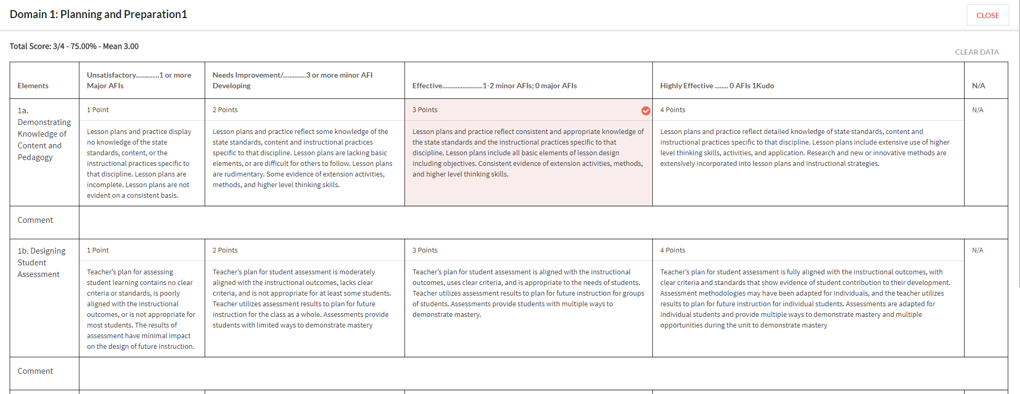

Figure 13. Full Proficiency Level Rubric

1. To save progress and return at a later time, click the *Save* button. Click *Submit* once the assessment has been completed (See Figure 14.) Note: All rubric elements, including those marked N/A must be selected prior to submitting.



1. Return to the class roster and select the next student to assess.

All courses should be reviewed at the beginning of the semester to ensure the content is accurate. If changes need to be made please let us know. Changes cannot be made after scoring has begun, so please review carefully. If you have any questions or issues with using Via, you may contact Vanessa Lavender or Veronica DeLeon, or you can call the Watermark customer service number.

College of Education Via Team:

Vanessa Lavender ([vlavender@fgcu.edu](mailto:vlavender@fgcu.edu) | 239.590.7359)

Veronica DeLeon (vdeleon@fgcu.edu)239-745-4529

Watermark Customer Service (1-800-311-5656)