At the FGCU College of Education, we use Via as an assessment tracking tool to manage and report our students’ progression toward graduation. All College of Education majors and graduate students are required to purchase Via, a one-time purchase. After logging into Via, you will need to accept the terms of use and submit a payment; as a faculty member, you do not pay for the benefit of Via. If you are prompted to pay, please contact Vanessa Lavender (contact information below).
To log in to Via:
- Proceed to www.vialivetext.com. Use only Chrome or Firefox. Safari will not work.
- Enter complete FGCU e-mail (See Figure 1.)
- Enter your unique Password if you do not remember you will need to recreate a new one. Continue to step 4 if you need to recreate a password.
- Click “Forgot Your Password?” to create a password for your account.
- Click the Sign-in icon (See Figure 1.)
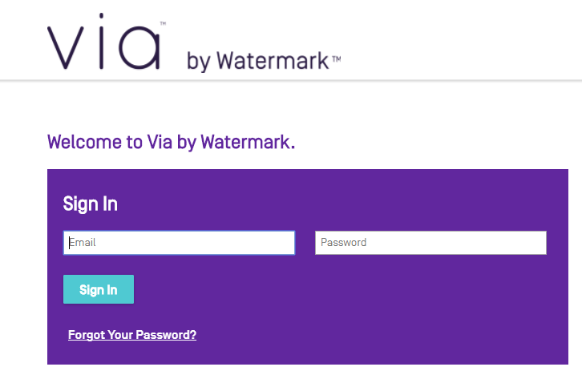

Follow the steps to reset your password, and you will should be able to access Via software going forward. If you are prompted to purchase Via, or if you have any questions or issues with using Via, you may contact the COE Via team, or you can call the Watermark customer service number.

College of Education Via Team:
Vanessa Lavender (vlavender@fgcu.edu | 239.590.7359)
Veronica DeLeon (vdeleon@fgcu.edu) | 239.745.4529) Field Experience
Watermark Customer Service (1-800-311-5656)

