Emergency Time Tracking
Payroll Job Aid for OPS

To begin work, an OPS employee logs into Workday, clicks the Time tab, then selects the Check-In button.
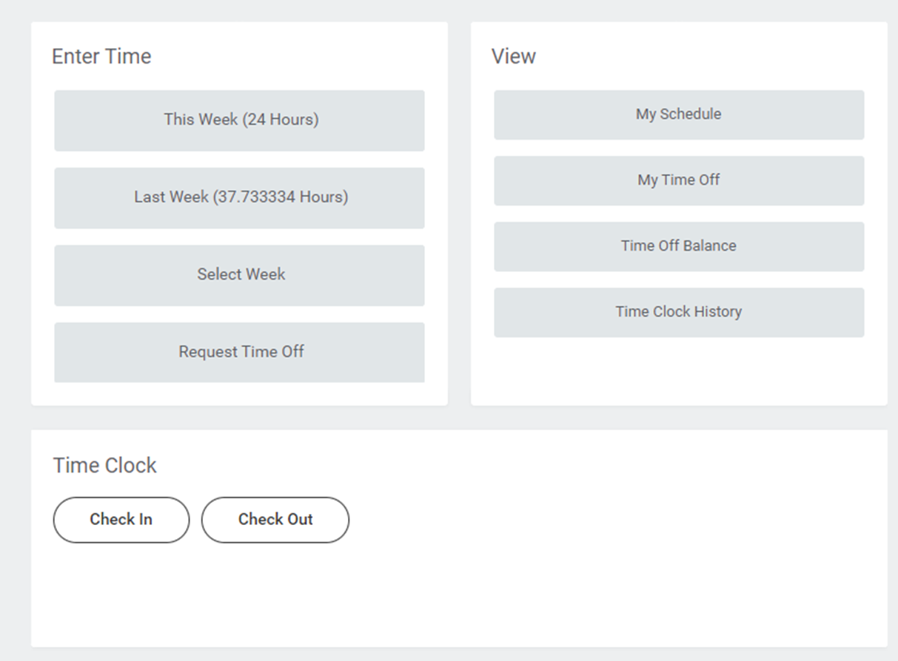
Select the time type dropdown menu. From the presented options, select Emergency Closure (Worked OPS).
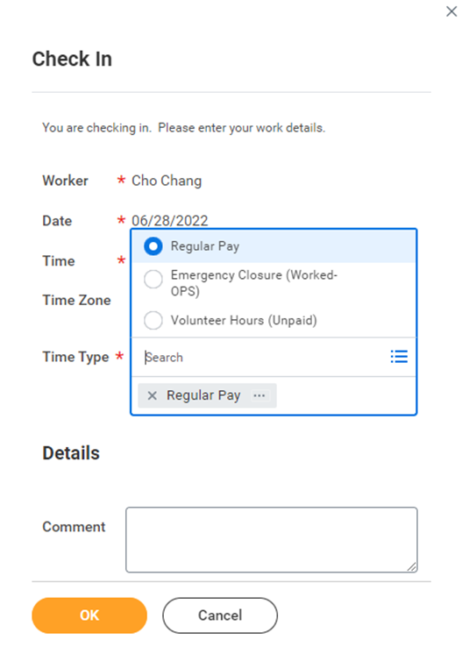
In the Emergency Closure Category box, click the three bars to access another drop-down menu. On that menu, click Emergency Closure Category (CWT 01) then select the applicable job description.
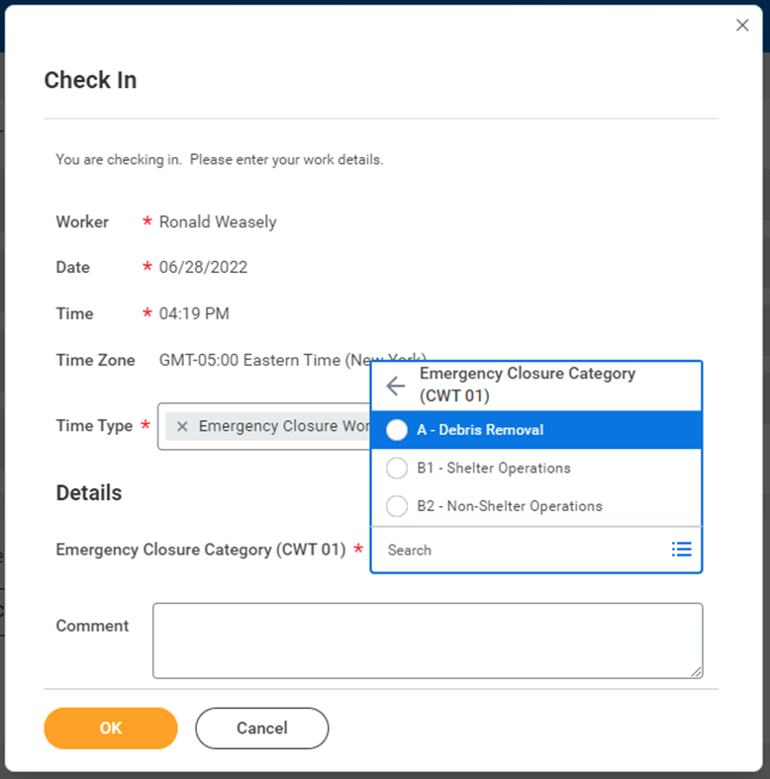
Once the shift has concluded, the category of work has changed, or you are beginning a break, the OPS employee will log back into Workday, select the Time tab, and click the Check-Out button.
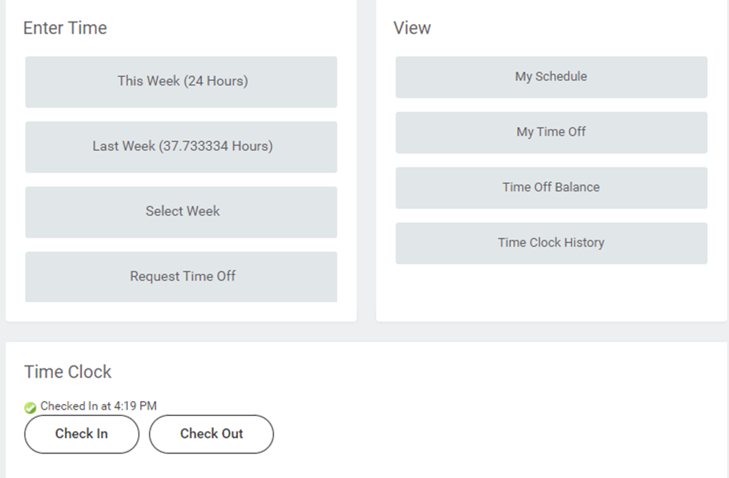
In the Comment section, enter the work completed and location(s). This comment regarding tasks performed and location is essential for FEMA reimbursement.
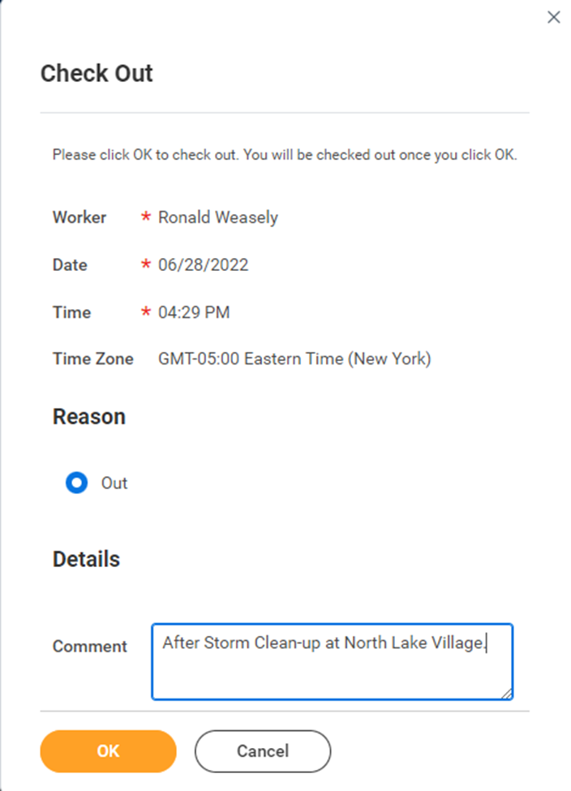
Submit the timesheet as usual. NOTE: Overtime is automatically calculated in the Workday system for hours worked over 40 per week.
