Emergency Time Tracking
Payroll Job Aid for Support Personnel

It is recommended that Support Personnel keep track of their time worked, breaks taken, and activities on a paper Emergency Time Tracking sheet for accuracy. Once you are ready to log your hours, log into Workday, open your time sheet, and click to Enter Time.
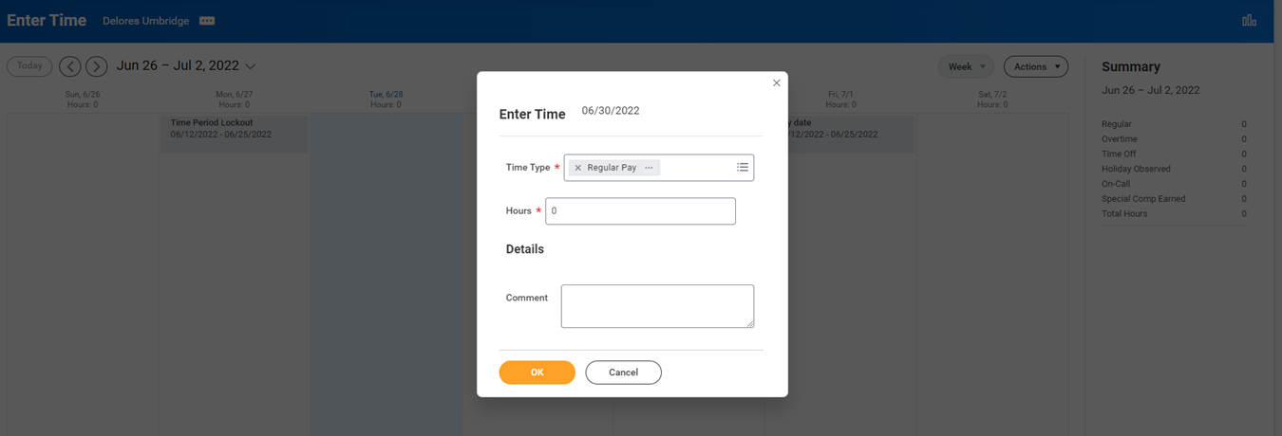
Select the time type dropdown menu. From the presented options, select Emergency Closure (Worked). NOTE: Overtime is automatically calculated in the Workday system for hours worked over 40 per week.
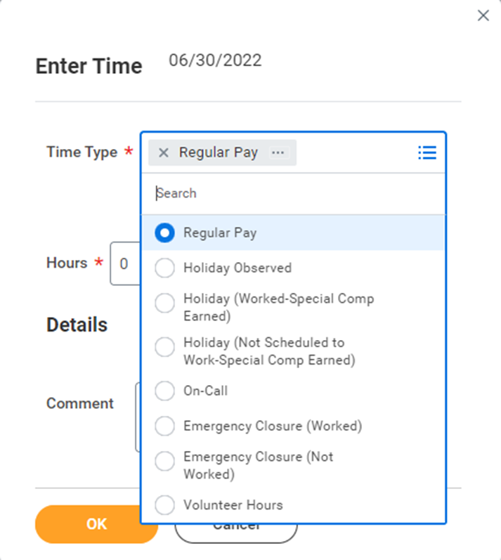

In the Hours section, enter the number of hours worked for that time period. In the Details section, click the 3 bars to access the drop-down menu. From the presented options, click the emergency closure category applicable to the work completed.
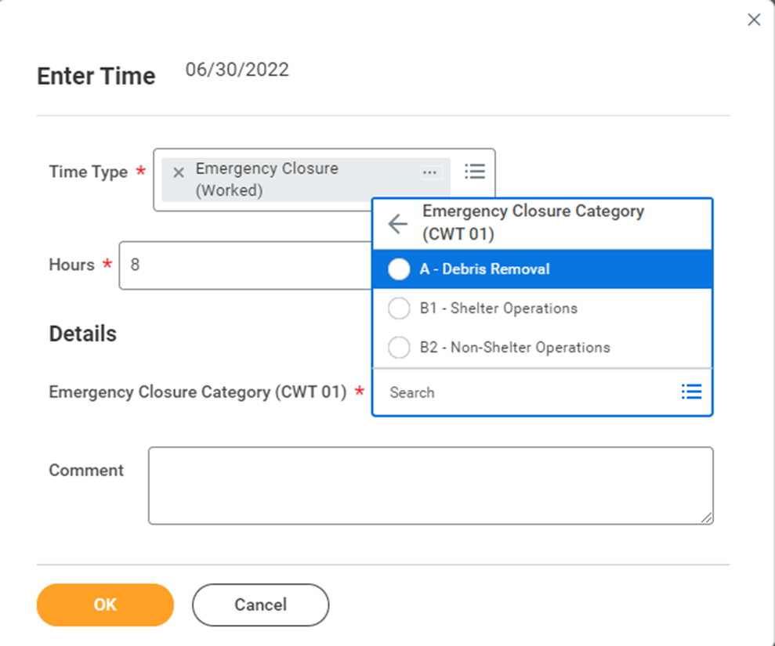
If the time worked for the day DOES NOT at least equal the normal number of hours worked each day, an additional step should be taken. Select the time type dropdown menu. From the presented options, select Emergency Closure (Not Worked) and enter the additional hours needed.

In the Comment section, enter the work completed and location(s). If you are working remotely, you can use the phrase, “via remote access.” This comment regarding tasks performed and location is essential for FEMA reimbursement.
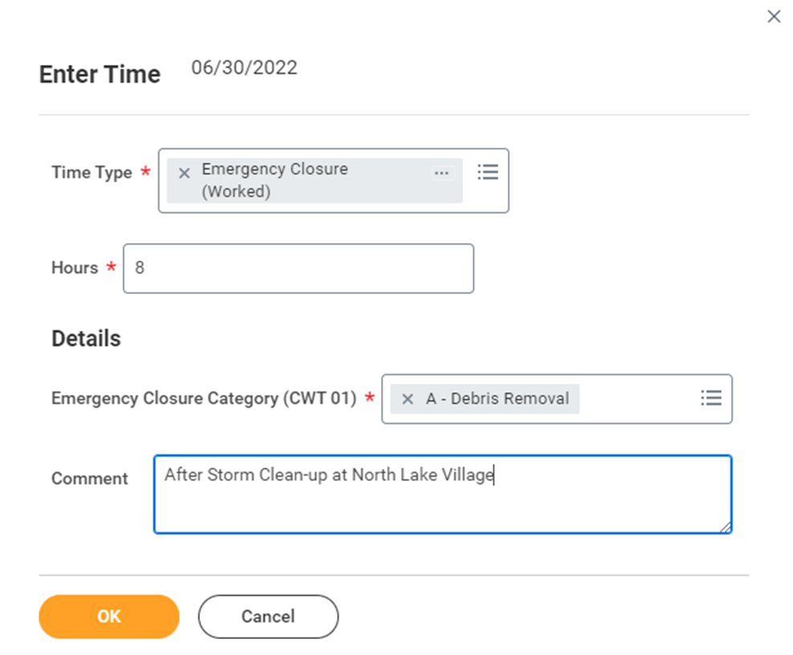
If you are working additional hours, are assigned to a different location, or are performing a different emergency assignment, you will need to repeat this process to document the hours for each specific location or assignment. Submit the timesheet as usual.
