Florida Gulf Coast University

Fort Myers, FL, US

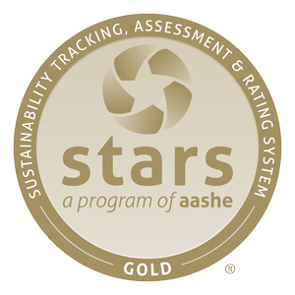

Rating | Score | Liaison | Submission Date | President's Letter | Export
Gold | 67.40 | Katie Leone | July 28, 2014 | Download | Download
Full report: https://stars.aashe.org/institutions/florida-gulf-coast-university-fl/report/2014-07-28/
Scoring Details: http://www.aashe.org/files/documents/STARS/2.0/stars_2.0_technical_manual_-_administrative_update_two.pdf

The Sustainability Tracking, Assessment & Rating System (STARS) is a program of AASHE, The Association for the Advancement of Sustainability in Higher Education. STARS is a sustainability-focused system which assess environmental, social, and economic factors contributing to campus resiliency. STARS has been developed by the higher education community through a transparent process. STARS is designed to:
  - Provide a framework for understanding sustainability in all sectors of higher education.
  - Enable meaningful comparisons over time and across institutions using a common set of measurements developed with broad participation from the campus sustainability community.
  - Create incentives for continual improvement toward sustainability.
  - Facilitate information sharing about higher education sustainability practices and performance.
  - Build a stronger, more diverse campus sustainability community.
  - Reporting is voluntary. STARS is a self-assessment, so schools can elect to complete the report in its entirety or report on certain credits.
FGCU’s STARS 2.0 SCORECARD
Submitted July 28, 2014

Category | Credit | Status | Points
Academics | Curriculum | Complete | 35.30 / 40.00
 | Research | Complete | 18.00 / 18.00
Engagement | Campus Engagement | Complete | 16.35 / 20.00
 | Public Engagement | Partially Pursued | 15.87 / 21.00
Operations | Climate & Air | Complete | 4.43 / 11.00
 | Buildings | Complete | 2.13 / 8.00
 | Dining Services | Complete | 3.64 / 7.00
 | Energy | Complete | 5.30/ 10.00
 | Grounds | Complete | 3.00/4.00
 | Purchasing | Partially Pursued | 2.16/6.00
 | Transportation | Complete | 3.34/7.00
 | Waste | Complete | 3.24/10.00
 | Water | Complete | 2.00/5.00
Planning  &  Administration | Coordination, Planning & Governance | Complete | 8.00/8.00
 | Diversity & Affordability | Complete | 8.93/10.00
 | Health, Wellbeing & Work | Complete | 2.97/7.00
 | Investment | Not Pursued | 0.00/7.00
Innovation | Innovation (bonus points) | Partially Pursued | 1.00/4.00

