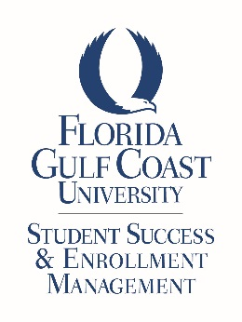

2019 FGCU HALL OF FAME
Division of Student Success and Enrollment Management

APPLICATION

Full Name: (Name You Are Called)

FGCU Classification (check one) UG or GR University Identification #:

Major: Cell Telephone#:

E-mail:

Local Mailing Address: _

Permanent Address:

Parents’/Guardians’ Names and Address (if different from above):

Your Hometown and State:

Expected Graduation Month and Year:

Total Hours Enrolled This Term: _ Total Hours Completed at FGCU: _

Total Number of Completed Semesters You Attended Full-Time at FGCU:

Cumulative GPA at FGCU: I am in good academic and conduct standing YES or NO

By applying for the Florida Gulf Coast University Hall of Fame, I give my consent to the selection committee to review my academic and disciplinary records for the purpose of this selection process.

Signature: Date:

Please complete the following essay question in 750 words or less. Type the essay directly into the field below.
Discuss how your engagement in the community of FGCU (including academic and extracurricular) has or will advance/improve Florida Gulf Coast University.

Please provide a video:

Prepare a (3) minute video and upload it to You Tube. Introduce yourself and include how you will impact your community after graduation from FGCU.

Share the link here:
(Be sure to test it to make sure it works!)

Upon completing the information in this application, you must SAVE it and send it as an email attachment from your Eagle email account to tmccaslin@fgcu.edu

The deadline for submission is Monday, February 25, 2019 by 3:00pm

